***Interdisciplinary Perspectives on Arts and Technology***

DOI: 10.62160/IPAT54

**RESEARCH ARTICLE**

**Practice and Reflection on AI Motion Capture Technology in Dance Creation**

**Li Jiangmei**

School of the Arts, Universiti Sains Malaysia,Mian Campus:11800 Gelugor, Penang, Malaysia.

Email: lijiangmei@student.usm.my

ABSTRACT: With the rapid development of artificial intelligence (AI) technology, its involvement in the field of dance creation has become increasingly profound. In particular, within dance education and teaching, AI not only serves as a tool-based assistant but is also gradually demonstrating its potential as a co-creative subject. Taking AI motion capture technology as the point of entry, this study explores the evolving role of AI in contemporary dance creation and offers critical reflections on its implications. Three dance performance videos with fast, medium, and slow paces were selected, and corresponding 3D motion data were generated via the DeepMotion platform to conduct experimental creative practices. By comparatively analyzing the original dance performances and the AI-generated outputs, this study reveals the characteristics of algorithmic performance in motion recognition, rhythmic logic, and stylistic construction, while reflecting on how “non-human choreographic thinking” expands the possibilities of dance reconstruction and the boundaries of creation. The research aims to advance dance studies within the context of human–AI co-creation, considering how dance in the technological era can retain its corporeality and cultural essence while moving toward a more open and cross-disciplinary future.

Keywords: Dance Creation; Motion Capture Technology; AI-generated Movement; Human–AI Co-creation

1.INTRODUCTION

In recent years, the extensive application of artificial intelligence (AI) technology in the field of artistic creation has been driving profound transformations in artistic practices (Joshi & Chakrabarty, 2021; Gao et al., 2022). In disciplines such as music, painting, and literature, AI has already demonstrated strong creative potential (Feng, 2022). In the field of dance, AI’s involvement has also become increasingly deep, evolving from technical support in teaching assistance, motion capture, and dance generation to more creative and collaborative forms of artistic practice (Miko et al., 2025; Wang, 2024). AI is no longer a passive tool; rather, through its algorithmic logic, data-processing capacity, and non-human perspectives, it actively participates in the construction of dance language and the exploration of expressive characteristics, thereby becoming a co-creator in the dance-making process (Baía Reis et al., 2025). This restructuring of the human–AI collaborative relationship has sparked in-depth discussions concerning the ontology of dance, the subjectivity of creation, and the boundaries of art.

In particular, propelled by motion capture technology, choreographers’ embodied experiences are digitally translated into new creative resources (Sun, 2022). AI motion capture is not only used to record and reproduce movement but also to generate entirely new movement sequences, reshaping dance language and expressive features (Darda & Cross, 2023). Against this backdrop, critical questions emerge: How should dance art respond to technology’s deep participation? Do AI-generated dance languages possess artistic autonomy? And is the interaction between choreographers and algorithms giving rise to a new paradigm of collaboration?

As AI technology continues to develop, the traditional notion of the creative subject is undergoing transformation. AI is no longer simply a passive technical tool but is increasingly demonstrating its potential as a co-creative agent in dance generation (Zhou et al., 2024). Drawing on posthumanist theory, this study explores new relationships between the body and algorithmic systems, focusing particularly on how the logic of movement generation and the subjectivity of dance are reconfigured in the creative process when AI motion capture technology is involved.

Posthumanist theory emphasizes that humans are no longer the sole center of knowledge and creation, but rather coexist with technology, machines, non-human intelligences, and even the environment as part of a dynamic, interwoven system (Wilson & Jeevaraj, 2023). This perspective challenges the traditional human-centered view of dance creation, granting technological systems,such as artificial intelligence,a certain degree of co-creative agency (Shi, 2022). As Wilde & Sylvia (2024) point out, the posthuman subject is a de-bordered, cross-species, and cross-media mode of existence that transcends the binary divisions between human/machine, nature/technology, and organic/inorganic. Such a conceptual framework provides the theoretical basis for reinterpreting the role of AI in dance creation.

In the application of AI motion capture, algorithmic systems are not merely tools for recording and imitation; rather, through their inherent computational logic, learning models, and generative mechanisms, they reconstruct dance movements at the level of data (Sun & Cui, 2024). This signifies that the process of dance creation is no longer entirely dominated by humans, but is gradually transforming into a dynamic, co-generative system of human-AI collaboration(Pang & Niu, 2023). The bias, uncertainty, and mechanical qualities of algorithms are thereby transformed into new resources for dance language, expanding the expressive dimensions of traditional dance (He, 2021).

Building on this foundation, this paper focuses on the theme of experimental practice and reflection on AI motion capture in contemporary dance creation, using the DeepMotion platform to conduct experimental research. Three dance performance videos with fast, medium, and slow paces were imported to generate AI motion data, which were then compared with and analyzed against the original performances. The study aims to explore the multiple roles AI plays in dance creation, analyze its specific performance in motion recognition, stylistic construction, and rhythmic logic, and reflect on how human-AI co-creation influences the presentation and creative thinking of dance. Through a practice-oriented inquiry, this paper seeks to propose new pathways for integrating human-AI collaboration into dance creation in the technological era, while offering insights and prospects for the future development of collaborative models between humans and AI.

2.LITERATURE REVIEW

This section systematically reviews existing research on artificial intelligence, motion capture technology, and their integrated application in dance creation, aiming to clarify the current state of AI adoption in the arts and to identify the research gap addressed by this study. The review encompasses the developmental trajectory of motion capture technology, its applications in dance education and performance studies, the emergence of AI as a co-creative force, and theoretical debates surrounding digital corporeality and posthumanism. By synthesizing these perspectives, this section positions the study within a practice-based, exploratory research framework, emphasizing the necessity of micro-level analyses of AI’s role in motion recognition, rhythmic logic, and stylistic construction.

Motion capture technology has undergone significant evolution and now holds considerable relevance in the arts. Motion capture refers to the process of recording human movement and converting it into digital models for analysis, reproduction, or creative reconstruction (Rigoni et al., 2023). Initially, this technology relied on optical systems that required reflective markers attached to performers’ bodies (Pueo & Jimenez-Olmedo, 2017). It subsequently advanced to inertial sensor-based systems, using accelerometers and gyroscopes to achieve greater flexibility and mobility (Feng et al., 2013; He et al., 2022). In recent years, markerless motion capture powered by deep learning algorithms has enabled motion reconstruction from standard video inputs (Xu, 2019), reducing costs and making motion data more accessible to artists, educators, and independent creators (Wu & Lian, 2021). While these technological developments have expanded creative possibilities, existing literature has largely focused on technical efficiency, with limited exploration of their artistic implications and influence on choreographic logic,an important gap that this study seeks to address.

The application of motion capture in the field of dance has historically focused primarily on education and research, with early studies emphasizing biomechanics and technical training rather than choreographic exploration. Scholars have used motion capture to analyze body alignment, movement range, and posture correction, aiming to prevent injuries and optimize technical training (Veirs et al., 2022; Chen, 2024; Zhou & Huang, 2024). While these studies have contributed to the advancement of dance training methodologies, they have rarely addressed choreography or artistic experimentation. As a crucial bridge between dancers’ bodies and digital systems, motion capture technology has facilitated the digitization and archival study of dance (Zhang, 2022; Veirs et al., 2022; Meng, 2022). The emergence of AI-driven platforms such as DeepMotion has further transformed motion capture from a functional recording tool into a generative creative instrument, enabling real-time skeletal modeling, personalized virtual characters, and immersive stage design (Li, 2021). However, its application in dance remains predominantly technical, and its creative potential is yet to be fully explored.

Artificial intelligence is increasingly being regarded as a potential co-creative agent in dance rather than merely a supportive tool. With the development of techniques such as Generative Adversarial Networks (GANs) and Recurrent Neural Networks (RNNs), AI can now generate novel movement sequences, enhance choreographic efficiency, and expand the expressive vocabulary of dance (Qiao & Shen, 2021; Zhang, 2024). Some scholars have introduced the concept of “other-than-human creativity,” suggesting that AI challenges conventional notions of authorship and prompts a rethinking of the artist–technology relationship (De Filippo et al., 2023). However, these discussions largely remain at a theoretical level, lacking empirical exploration within dance practice,an important gap this study aims to address through practice-based research.

Posthumanist theory further enriches discourse on AI’s role in dance by redefining the body as a digitally constructed

phenomenon, thereby expanding the conceptual dimensions of choreographic practice. Scholars argue that AI-generated bodies are not merely physical reproductions of movement but symbolic and encoded entities that can be deconstructed, reorganized, and creatively reconstructed (Li, 2024; Liu, 2024). The debate over whether AI can be considered a creator is not only a technical issue but also a deeper inquiry into authorship and the definition of art (Du et al., 2023). Posthumanism emphasizes the agency of AI as a non-human subject, disrupting the traditional subject–object dichotomy and reshaping understandings of agency in dance (Bar-Gil, 2023). While these theoretical perspectives offer significant conceptual value, they still lack empirical studies demonstrating their application in actual creative processes.

Interdisciplinary research in fields such as media, gaming, and extended reality (XR) demonstrates the creative potential of motion capture while also revealing its potential risks. For example, markerless motion capture technology has been widely employed in the development of hyper-realistic animated characters and interactive virtual performances, influencing dance experimentation in both online and offline environments (Yao, 2020; Yue, 2025). These innovations illustrate how technology is reshaping the relationship between audiences and performers but have also raised concerns about the “over-technologization” of dance and the potential dilution of its emotional and cultural dimensions (Jae, 2024). Consequently, striking a balance between technological reproduction and artistic generation has become a critical challenge in AI-driven dance creation.

Existing studies can generally be categorized into three main orientations: technical, educational, and philosophical. However, each approach has limitations in examining AI’s impact on dance creation: technical studies emphasize precision and efficiency, educational research focuses on pedagogy and movement analysis, and philosophical discussions center on authorship and the cultural significance of AI. Few studies integrate artistic practice, movement analysis, and theoretical exploration to holistically investigate how AI reshapes the language of dance. There remains a lack of empirical studies that position creative practice as the core of inquiry, encompassing the entire process from motion capture to generation and reflection. In particular, micro-level analyses of AI’s role in motion recognition, stylistic construction, and rhythmic logic remain insufficient. This gap underscores the importance of adopting practice as both a research methodology and an analytical tool.

Practice-based small-sample studies provide methodological support for the design of this research, as practice-led inquiries often prioritize depth over breadth to derive nuanced and insightful conclusions. Sandelowski (1995) argues that qualitative studies employing small sample sizes can achieve deep insights through high-quality data and rigorous analysis. Boddy (2016) highlights their effectiveness in capturing fine-grained characteristics and fostering theoretical innovation, while Starman (2013) emphasizes the value of case studies in the social sciences and arts for generating theory, particularly in the exploration of emerging phenomena and creative contexts.

Practice-Based Research places creative practice at the core of inquiry and is widely applied in art, design, and performance studies. Gavish and Stevens (2020) contend that research frameworks based on single or small numbers of works can generate valuable materials for dance creation or performance studies and promote interdisciplinary methodological innovation. Unlike traditional approaches that prioritize theory or empirical data, Practice-Based Research emphasizes knowledge generation through practice, positioning artistic creation, technological experimentation, and reflective analysis as integral research outputs (Lewandowska & Bojnarowicz, 2025; Blumenfeld-Jones, 2016; Candy & Edmonds, 2002). Following this framework, this study employs DeepMotion as a platform and selects three dance performance segments with varying rhythms. By applying AI-driven motion capture technology to generate motion data and comparing it with the original performance segments, the study explores AI’s role in movement recognition, stylistic construction, and rhythmic logic. The aim is to reveal the generative logic of human–AI collaboration and provide both practical examples and theoretical contributions for interdisciplinary research on dance and AI.

In conclusion, while existing literature offers valuable insights into technological development, educational applications, and theoretical debates, there remains a lack of practice-based empirical research that concretely examines AI’s influence on dance creation. This study, therefore, adopts a practice-based qualitative methodology to address this gap and contribute to scholarly discussions on the transformation of dance creation in the digital age.

**3.METHODOLOGY**

This study aims to explore, through experimental dance creation practice, the practical performance mechanisms and artistic potential of AI-based motion capture technology in contemporary dance, with particular focus on its roles in motion recognition, style construction, and rhythmic logic. To this end, the following sections will systematically present the research methodology, data collection methods, data analysis approaches, and the theoretical framework underpinning the study.

**3.1 Method**

This study adopts a practice-based qualitative research methodology. Practice-based research emphasizes artistic experimentation and critical reflection as primary modes of inquiry, making it particularly suitable for studies situated at the intersection of technology and the performing arts (Blumenfeld-Jones, 2016; Mainwaring & Aujla, 2023). Rather than relying on large-scale data collection to generate generalizable findings, this study focuses on depth of inquiry, seeking to uncover how technology participates in and influences dance language through reflective analysis of the choices, generative processes, and negotiation mechanisms embedded in creative practice.

Specifically, this research centers on experimental creative practices involving collaboration between a human dancer and AI-generated outputs. Three dance videos with distinct paces—fast, medium, and slow—were deliberately selected to maximize diversity in motion data. These videos were processed using the DeepMotion platform to generate corresponding three-dimensional motion data, which was subsequently used for experimental reconstruction. Analysis was then conducted across three key dimensions: movement recognition, rhythmic logic, and stylistic construction.

Although only three dance samples were selected, they were purposefully chosen for their specificity and high information value, aligning with qualitative research principles. The selection of fast, medium, and slow paces segments was designed to capture a broad range of movement characteristics and expressive variations, ensuring diversity and saturation in technical recognition and choreographic logic analysis. When research emphasizes depth over quantitative generalization, small samples can still yield powerful insights (Sandelowski, 1995). In dance research and practice-based studies, the use of a limited number of works,even a single work,as research material is both reasonable and common (Gavish & Stevens, 2020). Methodological scholars such as Patton (2015) and Boddy (2016) emphasize that purposive sampling of a small number of high-information cases can provide profound insights, while Starman (2013) highlights the value of single or small-case studies in generating theoretical contributions that can exceed those of large-sample studies. In practice-led dance research, purposive sampling allows a focus on key movements and outputs, extracting nuanced understandings of human-AI collaborative creation mechanisms from a limited dataset. Guided by these principles, this study applies in-depth experimental analysis of representative samples to explore AI’s role as a co-creator, contributing to the establishment of an experimental research paradigm in dance studies that integrates embodied performance with artificial intelligence.

In this study, the concept of “practice” has a dual orientation. On one hand, it refers to the dancer’s embodied performance of the dance; on the other, it encompasses the entire process through which the technical system perceives, encodes, reconstructs, and outputs these movements. By describing the mechanism of human–AI collaborative generation, this research seeks to move beyond the traditional binary structures in dance studies,body vs. technology, creator vs. tool,and instead explores the potential and limitations of technology as an active participant in the generation of dance language and expressive features.

**3.2 Data Collection**

To investigate in depth the generative effects of AI motion capture technology under different rhythmic conditions, this study designed and recorded three representative dance segments corresponding to three pace types: fast, medium, and slow. Each segment was kept 40 seconds in duration, ensuring a clear distinction of rhythmic features while preserving the dancer’s freedom of movement and creative spontaneity.

To ensure the reproducibility and comparability of the experiment, this study clearly defined the dance styles and levels of movement complexity in its experimental design. All dance segments were selected from contemporary dance works in order to maintain stylistic consistency and highlight the contemporary expressive characteristics of the movement language. Movement complexity was categorized into three levels—low, medium, and high—based on the number of movement elements, the degree of bodily involvement, and the extent of spatial and rhythmic variation. Low complexity refers to movements involving a single limb, with high repetitiveness and regular rhythm. Medium complexity includes two to three types of movement elements, accompanied by moderate spatial and rhythmic variations. High complexity involves full-body coordination and incorporates advanced movements such as jumps, turns, and multi-layered spatial utilization. These criteria provide a unified standard for subsequent analysis and ensure the comparability of research findings.

To create a stable and comparable experimental environment, all dance performances were conducted in the same venue to facilitate accurate motion recognition by the AI system. For accompaniment, the fast, medium, and slow paces were selected to guide the dancer in producing bodily expressions with distinct rhythmic layers while preserving elements of improvisation and originality. Without any preset choreography, the dancer responded naturally to the rhythms, generating a dynamic and varied dance vocabulary.

Recording was carried out with an HD camera (1080p) under natural lighting to ensure the clarity and visibility of movement details. Upon completion, the three dance videos were uploaded to the AI motion capture platform DeepMotion. Powered by deep learning,based motion estimation algorithms, the platform automatically detects the two-dimensional image sequences in the videos and converts them into three-dimensional skeletal animation data (output formats including BVH or FBX), generating a digital body model that closely matches the original movements.

Each dance video thus generated a corresponding set of 3D motion data, which could be replayed and analyzed through the platform’s built-in visualization interface. The researcher conducted a comparative study between the original dance videos and the AI-generated versions, focusing on three aspects: motion recognition, rhythmic logic, and style construction. Through this closed-loop workflow of “original performance → digital generation → feedback analysis,” the study effectively revealed the ways and mechanisms through which AI systems participate in dance creation, providing a solid data foundation and comparative framework for subsequent in-depth analysis.

**3.3 Data Analysis**

This study adopts Multimodal Content Analysis (MCA) to comprehensively interpret the multidimensional expressions involved in the integration of AI motion capture technology into contemporary dance creation (Wysoczanska & Trzcinski, 2020). This method synthesizes the analysis of texts, images, videos, movements, and other symbolic systems and their interactions, emphasizing the collaborative role of different modalities in meaning-making (Piana et al., 2016; Wu, 2023). In practice, the research combines original dance performance videos with AI-generated three-dimensional motion data, conducting detailed comparisons and analyses in terms of motion recognition accuracy, the degree of rhythmic logic restoration, and the consistency of style construction. By integrating visual, kinetic, and textual information, this approach not only reveals changes in dance expression under technological intervention but also uncovers the interplay among modalities in shaping dance language and creative logic. Ultimately, it provides a systematic analytical framework for reflecting on the boundaries of dance creation in the context of human–AI co-creation.

To ensure the transparency and reproducibility of the research process, this study provides further clarification on the specific steps of multimodal content analysis. First, regarding the coding rules, a coding system was established based on three dimensions: motion recognition, rhythmic logic, and stylistic construction. “Motion recognition” focuses on the spatial trajectories and range of motion of body parts; “rhythmic logic” evaluates the degree of alignment between movements and musical beats as well as the coherence of movement transitions, adopting quantifiable measures; “stylistic construction” is determined through the uniqueness of movement combinations, symbolic features, and the coordination of bodily expression. Second, in terms of the analytical framework, this study adopts a frame-by-frame comparative method across the three dimensions (motion recognition, rhythmic logic, and stylistic construction), comparing original dance performance videos with AI-generated motion data, with results presented in the form of tables or coding matrices. Finally, to reduce subjective bias, quantifiable indicators are set under each dimension, such as beat-matching rate (%), movement duration (seconds), and repetition frequency (counts), thereby enhancing the objectivity and verifiability of data analysis.

In the specific analysis, the focus is placed on the following aspects. In motion recognition, the analysis focuses on phenomena such as:path simplification, dynamic compression, or directional errors in movements; interruptions in movement continuity;reorganization or standardization of high-difficulty movements. In rhythmic logic, the study examines whether the AI system can reproduce the original complexity of rhythmic structures and the underlying breathing logic in dance, with particular attention to:preservation of rhythmic tension in fast segments(e.g., accelerate-pause-accelerate); completeness of the “initiation-development- transition-closure” structure in medium-paced segments;accurate rendering of breath-synchronized bodily extensions in slow-paced segments.In style construction, the analysis investigates whether the AI motion capture process exhibits any default stylistic tendencies, based on indicators such as:symmetry, simplicity, and regularity of movements;degree of preservation of individualized details (e.g., hand tremors, asymmetric twists);diversity of spatial configurations and range of bodily use.

**3.4 Theoretical Framework**

This study draws on **posthumanist theory** to explore the emerging relationships among human choreographers, embodied dancers, and algorithmic systems,particularly how the logic of movement generation and the subjectivity of dance are reconstructed when AI motion capture technology intervenes in the creative process.

Posthumanism challenges the anthropocentric cognitive framework, advocating for an understanding of humans, technology, and the environment as a coexisting and mutually constitutive network (Gündüz, 2007; Stalpaert et al., 2021). In the field of dance, this entails breaking away from the traditional assumption that the creator equals the human dancer, and instead recognizing algorithms and technologies as co-agents in shaping choreographic intentions and movement structures (Radia, 2023). Through this theoretical lens, AI motion capture is not merely a tool for recording movement, but a system that,by processing, filtering, and reconstructing movement data,exerts substantive influence on the choreography itself.

Recent research in **generative art** and **algorithmic aesthetics** has suggested that AI possesses a certain degree of **creative agency**. Trained on large datasets and informed by machine learning models, AI is capable of developing distinctive generative logics within conditions of uncertainty and feedback mechanisms (Berman & James, 2015; Trajkova et al., 2023). In dance creation, AI motion capture not only simulates original movements but can also manifest autonomous deviations in motion recognition, rhythmic logic, and style construction, leading to stylistic heterogeneity and re-creativity.

At its core, AI motion capture translates bodily movement into three-dimensional data,a process that produces what can be called the **digital body** or the **re-coded body** (Chen, 2024). While this virtual body preserves movement trajectories, it loses human-specific qualities such as emotional tension, spontaneity, and muscular perception. Thus, this body is simultaneously present and absent, both real and fictional (Liu, 2024). This paradox becomes a key entry point for rethinking dance within a posthumanist framework and offers a critical dimension for analyzing the expressive characteristics of AI-generated movement.

Guided by posthumanist theory, this study examines the movement language and expressive features that emerge in AI-mediated dance generation, reflecting further on the possibilities of **non-human choreographic thinking**. This framework not only illuminates how AI participates in motion recognition, style construction, and rhythmic logic but also expands discussions surrounding authorship in choreography, modes of bodily presentation, and the future boundaries of dance. By comparing experimental results with original dance sequence, the study theoretically validates the ways AI influences both creative processes and cognitive perspectives.

In summary, posthumanism provides not only a theoretical foundation for AI’s involvement in dance creation but also prompts a redefinition of dance as a uniquely human form of expression. It constructs a multidimensional framework for understanding the role of AI motion capture in contemporary performing arts. In this study, this theoretical lens serves as a central tool for interpreting AI-generated movement and human–AI co-creation, underpinning the entire process of experimental analysis and reflection, while also opening new pathways for the development of dance research in the context of technological integration.

**4.FINDINGS**

This section presents in detail the performance outcomes and analytical findings of AI motion capture within the context of concrete dance creation practices, focusing on the expressive characteristics exhibited by the AI motion capture system in dance creation. By conducting a frame-by-frame comparison between original dance performance sequence and the 3D skeletal animations generated by the DeepMotion platform, the study analyzes the process from three dimensions: the accuracy of motion recognition, the degree of rhythmic logic restoration, and the consistency of style construction,revealing how AI intervenes in and influences the generation of dance.

In terms of motion recognition, the AI motion capture demonstrates marked variability when processing movements of different rhythms and complexities. The findings indicate that (see Figure 1):

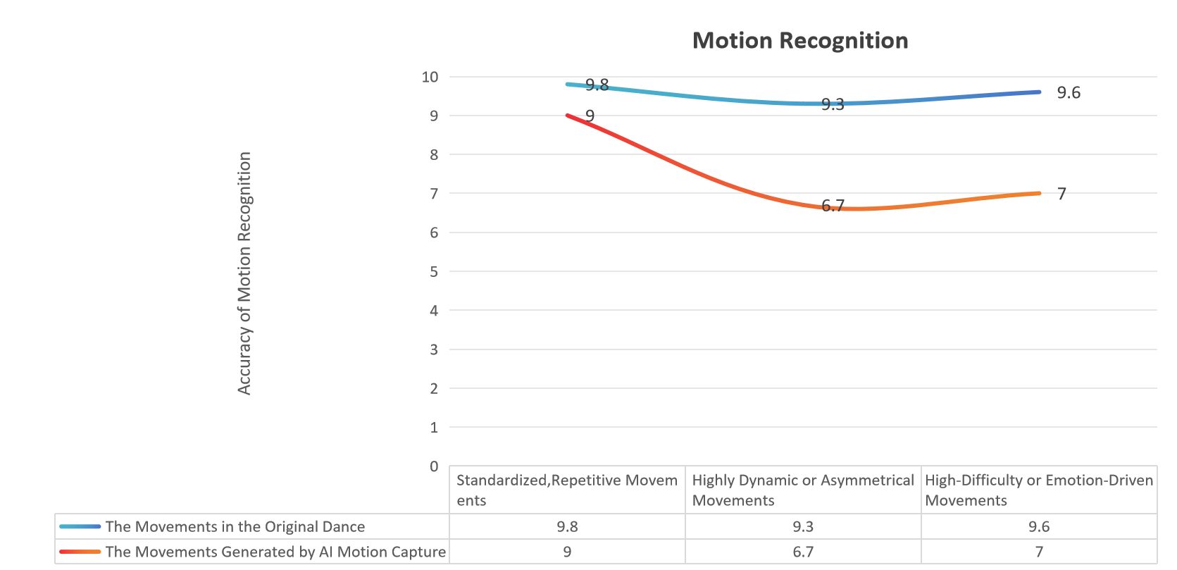

Figure 1. The Accuracy of Motion Recognition

* In standardized, highly repetitive movements, the AI motion capture achieves high recognition accuracy, with skeletal movements closely matching the original sequence.(see Figure 2)
* In highly dynamic or asymmetrical movements,such as a sudden pause after a jump, a rapid squat, or a body twist,the AI’s recognition tends to simplify movement paths and compress dynamics, with certain movements being reorganized into more computationally manageable structures.
* For certain high-difficulty or emotion-driven movements,such as a forward-leaning pause, arm tremors, or a sudden backward arch,the algorithm often applies smoothing processes or omits them entirely, resulting in a lack of movement tension and explosive impact.

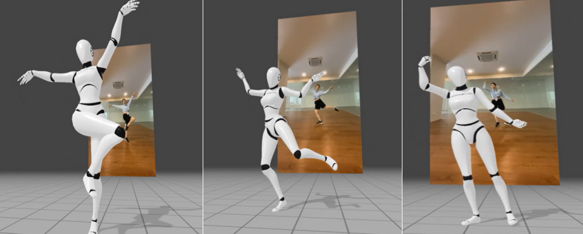

Figure 2. Standardized, Highly Repetitive Movements

It can thus be seen that AI motion recognition systems demonstrate stability in capturing linear and standardized bodily movements, yet still exhibit limitations in reproducing complex, personalized, and irregular dance vocabularies. Such recognition biases may diminish the emotional nuances and creative intentions embedded in the dancer’s physical language.

Rhythm, as the core organizing principle of dance, plays a decisive role in shaping both the emotional layers and structural integrity of expression. Through the analysis of dance segments with different rhythmic types, this study identifies the following characteristics of AI’s rhythm processing, as shown:(see Figure 3)

* In fast-paced segments, the original tension of the accelerate-pause-accelerate rhythmic pattern is flattened by the system, with the time intervals between movements being homogenized, resulting in blurred rhythmic layers and a lack of dynamic contrast.
* In medium-paced segments, the movement rhythm advances with an overly uniform logic, simplifying the original initiation-development-transition-closure internal rhythm structure into linear progression, thereby weakening the emotional buildup and sectional tension within the sequence.
* In slow-paced segments, the AI motion capture divides movements into equal-time beats, overlooking the *breath-synchronized extension-contraction structure* that synchronizes the dancer’s movements with breathing, making the performance appear rigid and diminishing emotional fluctuations.

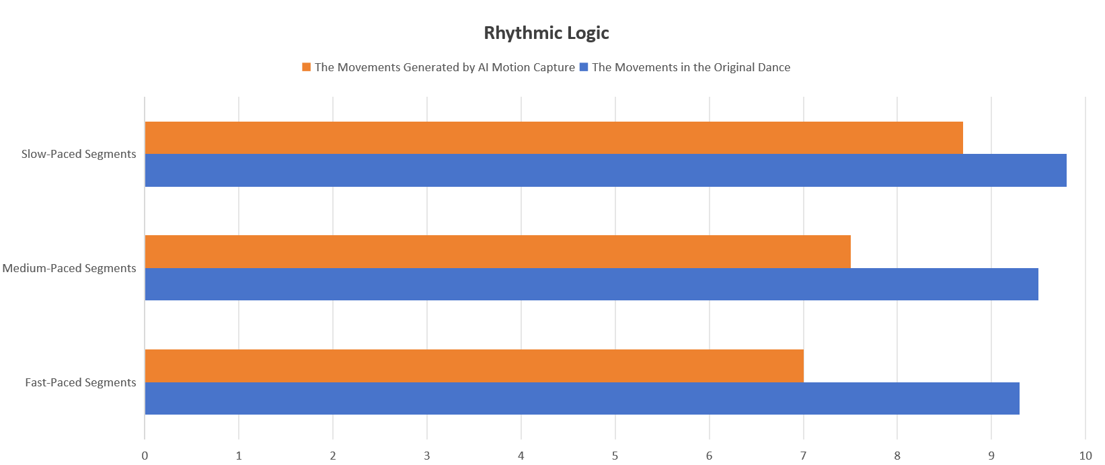

Figure 3. The Degree of Rhythmic Logic Restoration

This series of phenomena indicates that the current rhythm processing across segments of different paces generally exhibits a tendency toward equalization, overlooking the nuanced ebb and flow of rhythm and emotional movement present in the original dance performance. As a result, the expressive tension and narrative logic of the dance are weakened. The absence of such rhythmic logic not only diminishes the expressive power of the movement language but also, to some extent, severs the intrinsic connection between the dance and its emotional content.

Although the DeepMotion platform does not provide explicit style labels, observations of the generated motion data reveal that the AI motion capture demonstrates the following tendencies in dance style construction, as shown :(see Figure 4)

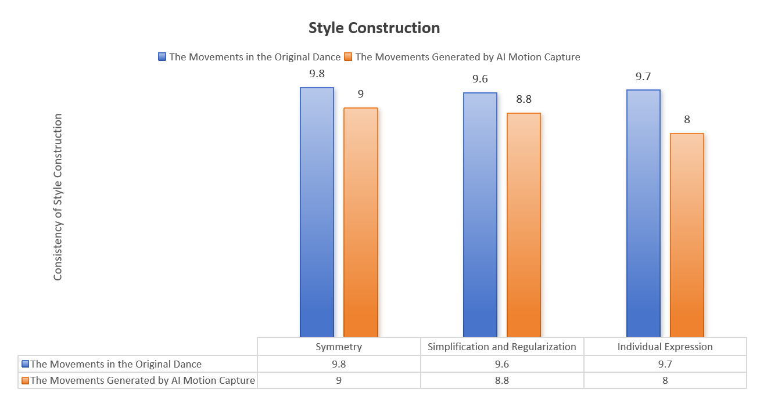

Figure 4. The Consistency of Style Construction

* **Symmetry prioritization:** AI tends to generate movement structures that are bilaterally symmetrical, reducing bias and asymmetrical compositions.(see Figure 5)
* **Simplification and regularization:** Hand details, tremors, and small-scale shaking movements are often ignored or smoothed out, emphasizing linear flow and minimalistic control.
* **Weakening of individual expression:** The emotional tension and stylistic features conveyed by dancers during improvisation are often processed into standardized outputs, resulting in the dilution of movement imprints that express personal style.

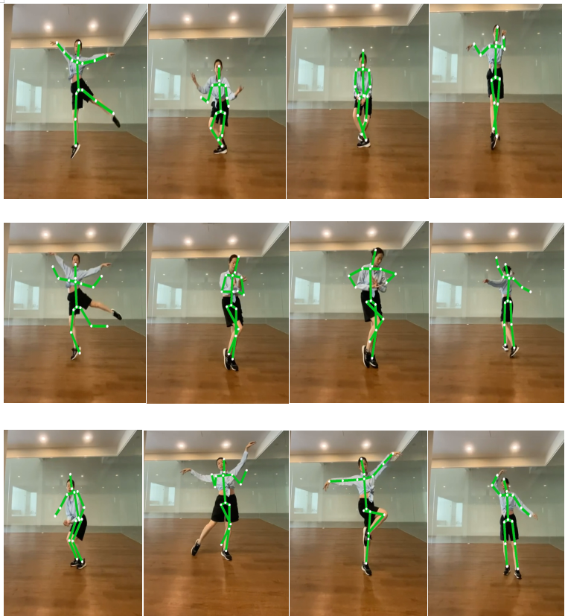

**Figure 5. AI Tends to Generate Movement Structures that are Bilaterally Symmetrical**

This stylistic preference reveals that AI motion capture, in its generative logic, tends to prioritize technical readability and physical feasibility over the preservation of emotional expression or individualized style. Such an unconscious stylistic choice reflects that, in the absence of emotion, motivation, and cultural context, AI motion capture is inclined to generate movements based on physical plausibility, thereby constructing a form of neutral aesthetics. This neutral aesthetics is not only an aesthetic inclination but also the product of the combined influence of algorithmic logic and system constraints.

From the perspective of posthumanist theory, this study finds that the algorithm underpinning the DeepMotion platform is neither neutral nor transparent. Its default settings favor a formal style characterized by clear structure, symmetrical movements, and balanced rhythm. Such embedded preferences subtly shape the generative tendencies of dance language, steering movement creation toward standardization and homogenization.

In this process, technology is no longer merely a neutral mediating tool but functions as a co-constructor of dance grammar, actively intervening in the creative practice. The algorithmic system plays a latent role in human–AI interaction,not directly dominating the creation, but quietly determining the overall framework and generative logic of movement through mechanisms such as technical parameters, movement recommendations, and rhythm modeling.

At the same time, the dancer’s role also undergoes transformation in collaboration with AI. Compared to the traditional body-led creative approach, dancers increasingly take on the role of dance directors or editors. Their creative action is no longer the direct output of movement but rather the repeated adjustment, negotiation, and integration of technology-generated results. This shift points to the emergence of a new mode of dance creation,negotiated generation,in which dance is no longer a product solely dominated by humans but a process of dynamic co-construction between human and AI.

In summary, through experiments and analysis of three dance segments, this study reveals the performance characteristics of AI motion capture systems in motion recognition, style reconstruction, and rhythmic logic. It finds that while AI enhances the efficiency of movement generation, it also exhibits a tendency to weaken the recognition of movement details, flatten stylistic reconstruction, and homogenize rhythmic logic. Therefore, while AI motion capture technology brings new possibilities to dance creation, it also exposes its structural limitations. This characteristic reminds us to maintain a critical awareness of AI’s involvement in dance practice and creation, and to explore how the mechanisms of movement generation and the subject of expression might be redefined in the context of technological co-creation.

5.DISCUSSION

This study adopts a practice-based approach, integrating the perspective of posthumanist theory and employing multimodal content analysis to explore the modes of intervention and expressive characteristics of artificial intelligence motion capture technology in contemporary dance creation. Through frame-by-frame analysis of three original dance segments with different paces and their AI-generated counterparts, the research examines three dimensions of movement recognition, rhythmic logic, and stylistic construction, in order to reveal the operative mechanisms and potential impacts of AI in the process of generating dance language.

The findings indicate that AI motion capture technology possess certain strengths in recognizing and generating standardized, highly symmetrical, and structurally clear movements, yet they show marked limitations in handling complex rhythms, emotional expression, and individual style. In terms of rhythm in particular, AI demonstrates a distinct tendency toward equalization, flattening the natural tension and breathing structure of the dance, thereby diminishing the layering and narrativity of emotional expression. Moreover, the AI generation process reflects a tendency toward neutral aesthetics, in which technical readability and physical plausibility serve as the core criteria, reshaping the stylistic orientation of dance language.

Such technical performance directly affects the presentation of dance language and expressive qualities. In original performances, a dancer’s bodily language often contains subtle variations in force, breath rhythm, and emotional flow,details that form an essential part of dance expressiveness. However, when generating motion data, AI tends to smooth the original motion trajectories, rendering them visually more fluid while simultaneously reducing irregularity and tension. As a result, the personalized qualities of the performance are diluted, leaning toward a homogenized, digitized dance language.

From the creator’s perspective, AI motion capture offers entirely new pathways for dance creation. The real-time generation and visualization of movement data enable choreographers to rapidly experiment with different combinations of movements and dance sequences without relying on extended in-person rehearsals. This traceable mode of creation alters the traditional logic of choreography, allowing creators to capture basic movements first and then refine or reconstruct them in a digital environment. In interacting with AI, dancers gradually shift from being traditional corporeal creators to becoming technological collaborators, engaging in a negotiated generative process through the adjustment, refinement, and intervention of AI-generated outputs. This fosters a new model of collaborative creation that introduces a pluralistic and co-creative logic into dance creation.

However, the convenience of technology comes with the potential weakening of dance’s liveness and embodied experience. When creation relies excessively on AI rather than bodily practice, the corporeal connection between the dancer and the work may be diminished, and dance language may tend toward datafication and templating. Nuanced bodily experiences such as perception, breath, and a sense of weight are often difficult for AI motion capture systems to fully reproduce or simulate. As a result, emotional expression and individual differences may be compressed within the range that algorithms can recognize and generate, thereby constraining the depth and diversity of dance art.

In summary, this study not only reveals the specific manifestations and potential issues of AI motion capture technology in dance creation but also offers new perspectives for understanding human-AI relationships. AI is no longer a neutral technological tool; rather, it has become an active participant in shaping dance language and expressive qualities. In future dance creation, the controllability and negotiability of technology will be crucial prerequisites for unleashing creative potential. The integration of AI into dance represents both a challenge and an opportunity. At the intersection of human-AI co-creation, dancers may no longer be isolated corporeal poets but could instead become cultural translators between algorithms and the body. How to embrace technology while maintaining corporeality and cultural rootedness will be a critical question for contemporary dance.

Looking ahead, AI motion capture technology has the potential to play a greater role in dance education, remote rehearsals, and virtual stages. For creators, the key lies in balancing technological convenience with artistic expression, ensuring that AI functions as an efficient creative tool without displacing the unique corporeality and liveness inherent to dance. The findings of this study suggest that technology should be regarded as a collaborator rather than a dominant force in dance creation, and that creators must actively guide the modes of technological participation to preserve the diversity and uniqueness of dance art within the digital wave.

6.LIMITATION

This study has several limitations, primarily concerning sample size and research scope. Three dance videos were purposively selected as the sample set to conduct an in-depth investigation of the human–AI collaborative creative process. This approach aligns with the characteristics of practice-based qualitative research, which emphasizes data richness and analytical depth rather than statistical generalizability (Sandelowski, 1995; Patton, 2015; Boddy, 2016; Starman, 2013). Although the limited number of cases inevitably constrains the breadth of conclusions, the deliberate selection of videos with varying tempos maximizes the diversity of motion data and artistic expression, thereby providing valuable insights into the technical impact of AI-assisted dance creation.

Another limitation lies in the study’s reliance on a single AI-based motion capture platform, which may affect the transferability of findings to other technological contexts. Future research could address these constraints by expanding the sample range, incorporating a broader variety of dance styles, integrating multiple AI systems, and employing mixed methods that combine quantitative measurement with qualitative insight.

7.CONCLUSION

This study centers on experimental practice to examine the application of AI motion capture technology in contemporary dance creation, with a particular focus on its potential, significance, and limitations. The findings reveal that AI motion capture not only opens up new possibilities for dance creation and reimagines the dancing body, but also faces challenges in preserving the subtlety of embodied experience and the individuality of dance language.

At the academic level, this research conceptualizes the digital body as a symbolically reconstructed existence through algorithms, rather than a mere reproduction of physical movement, thereby broadening the theoretical horizon in related studies. At the practical level, it emphasizes that choreographers and artists should, while embracing innovation through AI, remain critically attentive to embodied experience and the intrinsic language of dance.

Although the study is limited by the influence of a single dancer sample on AI recognition outcomes, it nevertheless lays a foundation for future research. Subsequent studies that incorporate performers from diverse dance backgrounds, systematically compare the performance of different AI motion capture platforms, and expand the size and variety of the dataset will contribute to a more comprehensive understanding of the role and potential of AI in dance creation.

**Acknowledgement**

The author would like to express sincere gratitude to all those who provided guidance, feedback, and support during the preparation of this study.Special thanks are also extended to the institutions and to the DeepMotion platform for enabling the use of AI motion capture technology, which facilitated the creative experimentation and exploration central to this study.

**Ethical Statement**

This study adhered to established ethical standards for research involving human participants. The sole participant was the researcher, who voluntarily engaged in all dance performance and AI motion capture activities. No other human participants were involved, and the study posed no risk of harm. All recordings and data were created exclusively for academic purposes, with the researcher retaining full rights to her image and performance.

**Conflicts of Interest**

The author declares no conflicts of interest related to this study.

**Data Availability Statement**

The datasets generated and analyzed during this study, including AI-based motion capture recordings, experimental outputs, and related creative materials, are not publicly accessible due to intellectual property rights and participant privacy considerations. Access to selected anonymized or processed data may be granted by the author upon reasonable request and with appropriate institutional or ethical approvals.

Author Contribution Statement

The author was solely responsible for the conceptualization, research design, data collection, analysis, and writing of this manuscript.

**REFERENCE**

1. Bar-Gil, O. (2023). The Dance of Agencies in AI Art–Beyond the Creator-Tool Dichotomy, a Netnographic Analysis of Reddit Forums. Journal of Posthuman Studies, 7(2), 129–149. <https://doi.org/10.5325/jpoststud.7.2.0129>
2. Chen, J. (2024). The Application of Pose Estimation Algorithm in Ballet Movement Analysis. In Y. Liu (Ed.), Second International Conference on Physics, Photonics, and Optical Engineering (ICPPOE 2023) (0 📊; p. 101). <https://doi.org/10.1117/12.3026811>
3. Chen, J. (2025). Research on Automatic Generation System of Dance Movements Based on Deep Learning. International Journal of High Speed Electronics and Systems, 34(01), 2540087. <https://doi.org/10.1142/s0129156425400877>
4. De Filippo, A., Giuliani, L., Mancini, E., Borghesi, A., Mello, P., & Milano, M. (2023). Towards Symbiotic Creativity: A Methodological Approach to Compare Human and AI Robotic Dance Creations. Proceedings of the Thirty-Second International Joint Conference on Artificial Intelligence, 6, 5806–5814. <https://doi.org/10.24963/ijcai.2023/644>
5. Feng, B., Zhang, X., & Zhao, H. (2013). The Research of Motion Capture Technology Based on Inertial Measurement. 2013 IEEE 11th International Conference on Dependable, Autonomic and Secure Computing, 238–243. <https://doi.org/10.1109/DASC.2013.69>
6. Feng, S. (2022). The Application of Artificial Intelligence Technology in the Field of Artistic Creation. In B. J. Jansen, H. Liang, & J. Ye (Eds.), International Conference on Cognitive based Information Processing and Applications (CIPA 2021) (3 📊; Vol. 84, pp. 537–543). Springer. <https://doi.org/10.1007/978-981-16-5857-0_69>
7. Gao, Z., Man, S., & Wang, A. (2022). AI Art and Design Creation Industry: The Transformation from Individual Production to Human-Machine Symbiosis. 2022 World Automation Congress (WAC), 52–56. <https://doi.org/10.23919/WAC55640.2022.9934515>
8. He, H. (2021). Research on Human Action Recognition in Dance Video Images. Journal of Physics: Conference Series, 1852(2), 022062. <https://doi.org/10.1088/1742-6596/1852/2/022062>
9. He, Q., Zheng, Z., Zhu, X., Zhang, H., Su, Y., & Xu, X. (2022). Design and Implementation of Low-Cost Inertial Sensor-Based Human Motion Capture System. 2022 International Conference on Cyber-Physical Social Intelligence (ICCSI), 664–669. <https://doi.org/10.1109/ICCSI55536.2022.9970563>
10. Jae, H. J. (2024). Between Creation and Generative Dance: A Consideration on AI and Choreography. Dance Research Journal of Dance, 82(1), 257–270. <https://doi.org/10.21317/ksd.82.1.14>
11. Li, Q. (2024). Application of Motion Capture Technology Based on Wearable Motion Sensor Devices in Dance Body Motion Recognition. Measurement: Sensors, 32. <https://doi.org/10.1016/j.measen.2024.101055>
12. Liu, W., & Hyung-Gi, K. (2024). Sublimation of Technology: The Impact of Artificial Intelligence on Esthetics and Artistic Expression. International Journal of High Speed Electronics and Systems, 2540175. <https://doi.org/10.1142/s0129156425401755>
13. Liu, Y. (2024). Vision-Based Robotic Dance Motion Capture System. 2024 IEEE 7th International Conference on Information Systems and Computer Aided Education (ICISCAE), 871–875. <https://doi.org/10.1109/ICISCAE62304.2024.10761905>
14. Piana, S., Coletta, P., Ghisio, S., Niewiadomski, R., Mancini, M., Sagoleo, R., Volpe, G., & Camurri, A. (2016). Towards a Multimodal Repository of Expressive Movement Qualities in Dance. 10, 1–8. <https://doi.org/10.1145/2948910.2948931>
15. Pueo, B., & Jimenez-Olmedo, J. M. (2017). Application of Motion Capture Technology for Sport Performance Analysis (el Uso De La Tecnología De Captura De Movimiento Para El Análisis Del Rendimiento Deportivo). Retos, 32, 241–247. <https://doi.org/10.47197/retos.v0i32.56072>
16. Rigoni, G., Monaco, N., Martinez, G. C., Cibin, F., Spolaor, F., Guiotto, A., & Sawacha, Z. (2023). Reliability of an Ai Driven 3-Dimensional Markerless Motion Capture System for on the Field Sport Applications. Gait & Posture, 106, S173–S174. <https://doi.org/10.1016/j.gaitpost.2023.07.210>
17. Shi, Y. (2022). Online Dance Guidance Intelligent System based on Online Video Action Recognition. 2022 3rd International Conference on Electronics and Sustainable Communication Systems (ICESC), 1337–1340. <https://doi.org/10.1109/ICESC54411.2022.9885516>
18. Sun, K. (2022). Research on Dance Motion Capture Technology for Visualization Requirements. Scientific Programming, 2022, 1–8. <https://doi.org/10.1155/2022/2062791>
19. Toverud Ruud, M., Hisdal Sandberg, T., Johan Vedde Tranvaag, U., Wallace, B., Mojtaba Karbasi, S., & Torresen, J. (2022). Reinforcement Learning Based Dance Movement Generation. Proceedings of the 8th International Conference on Movement and Computing, 1–5. <https://doi.org/10.1145/3537972.3538007>
20. Veirs, K. P., Fagg, A. H., Haleem, A. M., Jeffries, L. M., Randall, K., Sisson, S. B., & Dionne, C. P. (2022). Applications of Biomechanical Foot Models to Evaluate Dance Movements Using Three-Dimensional Motion Capture: A Review of the Literature. Journal of Dance Medicine & Science, 26(2), 69–86. <https://doi.org/10.12678/1089-313X.061522a>
21. Wang, Z. (2024). Artificial Intelligence in Dance Education: Using Immersive Technologies for Teaching Dance Skills. Technology in Society, 77. <https://doi.org/10.1016/j.techsoc.2024.102579>
22. Wilson, K. D., & Jeevaraj, A. E. (2023). Philosophical Posthumanism: A Renewed Worldview and a Methodological Framework for Critical Analysis. Journal of Posthuman Studies, 7(2), 170–190. <https://doi.org/10.5325/jpoststud.7.2.0170>
23. Wu, L. (2024). Evaluation on Multimodal Dance Action Recognition Based on Artificial Intelligence Image Technology. 112–117. <https://doi.org/10.1145/3616901.3616927>
24. Wysoczańska, M., & Trzciński, T. (2025). Multimodal Dance Recognition. 5, 558–565. <https://doi.org/10.5220/0009326005580565>
25. Zhang, L. (2022). Digital Protection of Dance of Intangible Cultural Heritage by Motion Capture Technology. International Conference on Cognitive Based Information Processing and Applications (CIPA 2021), 85, 429–436. <https://doi.org/10.1007/978-981-16-5854-9_54>
26. Zhang, L. (2024). Research on Automated Choreography and Real-time Adjustment of Cheerleading Performance Based on Artificial Intelligence. Applied Mathematics and Nonlinear Sciences, 9(1), 1–13. <https://doi.org/10.2478/amns-2024-2598>
27. Zhou, L., Zhao, J., & He, J. (2024). A Diffusion Modeling-Based System for Teaching Dance to Digital Human. Applied Sciences, 14(19), 9084. <https://doi.org/10.3390/app14199084>
28. Zhou, Q., Wang, J., Wu, P., & Qi, Y. (2021). Application Development of Dance Pose Recognition Based on Embedded Artificial Intelligence Equipment. Journal of Physics: Conference Series, 1757(1), 012011. <https://doi.org/10.1088/1742-6596/1757/1/012011>
29. Zhou, X., & Huang, J. (2024). Motion Capture Sensor-Based Pose Estimation for Dance Canonical Movements. Applied Mathematics and Nonlinear Sciences, 9(1), 20241154. <https://doi.org/10.2478/amns-2024-1154>
30. Baía Reis, A., Vašků, P., & Solmošiová, S. (2025). Artificial Intelligence in Dance Choreography: A Practice-as-Research Exploration of Human–Ai Co-Creation Using Chatgpt-4. International Journal of Performance Arts and Digital Media, 1–21. <https://doi.org/10.1080/14794713.2025.2515754>
31. Berman, A., & James, V. (2015). Kinetic Imaginations: Exploring the Possibilities of Combining Ai and Dance. 2431–2437. <https://scispace.com/papers/kinetic-imaginations-exploring-the-possibilities-of-2rkt1zzkqq>
32. Blumenfeld-Jones, D. S. (2016). The Artistic Process and Arts-Based Research: A Phenomenological Account of the Practice. Qualitative Inquiry, 22(5), 322–333. <https://doi.org/10.1177/1077800415620212>
33. Boddy, C. R. (2016). Sample Size for Qualitative Research. Qualitative Market Research: An International Journal, 19(4), 426–432. <https://doi.org/10.1108/QMR-06-2016-0053>
34. Candy, L., & Edmonds, E. (2002). Modeling Co-Creativity in Art and Technology. Proceedings of the Fourth Conference on Creativity & Cognition - C&c ’02, 134–141. <https://doi.org/10.1145/581710.581731>
35. Darda, K. M., & Cross, E. S. (2023). The Computer, a Choreographer? Aesthetic Responses to Randomly-Generated Dance Choreography by a Computer. Heliyon, 9(1), e12750. <https://doi.org/10.1016/j.heliyon.2022.e12750>
36. Du, W., Chen, J., & Xu, S. (2023). Exploring the Current Landscape and Future Directions of Information Technology in Dance Education. 2023 26th ACIS International Winter Conference on Software Engineering, Artificial Intelligence, Networking and Parallel/Distributed Computing (SNPD-Winter), 120–126. <https://doi.org/10.1109/SNPD-Winter57765.2023.10224030>
37. Gavish, M., & Stevens, C. J. (2020). Thinking Strategically about Dance Making: An Analysis of the Structuring Stage and the Strategies Choreographers Use for Varying Dance Works. Dance Research, 38(1), 41–64. <https://doi.org/10.3366/drs.2020.0290>
38. Gündüz, Z. (2012). Digital Dance: (Dis)entangling Human and Technology [PHD’s Theses]. University of Amsterdam.
39. Joshi, M., & Chakrabarty, S. (2021). An Extensive Review of Computational Dance Automation Techniques and Applications. Proceedings of the Royal Society A: Mathematical, Physical and Engineering Sciences, 477(2251), 20210071. <https://doi.org/10.1098/rspa.2021.0071>
40. Lewandowska, K., & Bojnarowicz, M. (2025). Practice-Based Educational and Theatre Research: A Scoping Review. British Educational Research Journal, 51(3), 1342–1371. <https://doi.org/10.1002/berj.4127>
41. Li, X. (2021). The Art of Dance from the Perspective of Artificial Intelligence. Journal of Physics: Conference Series, 1852(4), 042011. <https://doi.org/10.1088/1742-6596/1852/4/042011>
42. Mainwaring, L., & Aujla, I. (2023). Qualitative Methodologies. In T. Welsh, J. P. Ambegaonkar, & L. Mainwaring (Eds.), Research Methods in the Dance Sciences (pp. 180–196). University Press of Florida. <https://doi.org/10.5744/florida/9780813069548.003.0013>
43. Meng, Y. (2022). Design of Automatic Motion Capture Algorithm for Yao’s Long Drum Dance Based on Multieye Machine Vision. Scientific Programming, 2022(1), 1–10. <https://doi.org/10.1155/2022/1126020>
44. Miko, H., Frizen, R., & Steinberg, C. (2025). Using Ai-Based Feedback in Dance Education—A Literature Review. Research in Dance Education, 0(0), 1–25. <https://doi.org/10.1080/14647893.2025.2524160>
45. Pang, Y., & Niu, Y. (2023). Dance Video Motion Recognition Based on Computer Vision and Image Processing. Applied Artificial Intelligence, 37(1), 2226962. <https://doi.org/10.1080/08839514.2023.2226962>
46. Patton, M. Q. (2015). Qualitative Research & Evaluation Methods: Integrating Theory and Practice (4th ed). SAGE Publications, Inc. <https://cir.nii.ac.jp/crid/1971430859763109203>
47. Qiao, L., & Shen, Q. (2021). Human Action Recognition Technology in Dance Video Image. Scientific Programming, 2021(1), 1–8. <https://doi.org/10.1155/2021/6144762>
48. Radia, P. (2023). Becoming-Digit: Valentine de Saint-Point’s Posthumanist Futurism. In Modernism beyond the Human (Vol. 4, pp. 45–46). Brill. <https://doi.org/10.1163/9789004549685_004>
49. Sandelowski, M. (1995). Sample Size in Qualitative Research. Research in Nursing & Health, 18(2), 179–183. <https://doi.org/10.1002/nur.4770180211>
50. Stalpaert, C., van Baarle, K., & Karreman, L. (2021). Performance and Posthumanism: Co-Creation, Response-Ability and Epistemologies. In C. Stalpaert, K. van Baarle, & L. Karreman (Eds.), Performance and Posthumanism: Staging Prototypes of Composite Bodies (pp. 1–47). Springer International Publishing. <https://doi.org/10.1007/978-3-030-74745-9_1>
51. Starman, A. B. (2013). The Case Study as a Type of Qualitative Research. Journal of Contemporary Educational Studies, 64(1), 28–43.
52. Sun, Z., & Cui, Y. (2024). Exploring the Path of Innovative College Dance Teaching Models with Motion Capture Technology. Applied Mathematics and Nonlinear Sciences, 9(1), 1–13. <https://doi.org/10.2478/amns-2024-1302>
53. Trajkova, M., Long, D., Deshpande, M., Knowlton, A., & Magerko, B. (2024). Exploring Collaborative Movement Improvisation Towards the Design of LuminAI—a Co-Creative AI Dance Partner. Proceedings of the CHI Conference on Human Factors in Computing Systems, 1–22. <https://doi.org/10.1145/3613904.3642677>
54. Veirs, K. P., Fagg, A. H., Haleem, A. M., Jeffries, L. M., Randall, K., Sisson, S. B., & Dionne, C. P. (2022). Applications of Biomechanical Foot Models to Evaluate Dance Movements Using Three-Dimensional Motion Capture: A Review of the Literature. Journal of Dance Medicine & Science, 26(2), 69–86. <https://doi.org/10.12678/1089-313X.061522a>
55. Wilde, P., & Sylvia Iv, J. J. (2024). Introduction: Posthumanism and Media Studies. Journal of Posthumanism, 4(3), 169–176. <https://doi.org/10.33182/joph.v4i3.3451>
56. Wu, Z., & Lian, L. (2021). Physical World to Virtual Reality – Motion Capture Technology in Dance Creation. Journal of Physics: Conference Series, 1828(1), 012097. <https://doi.org/10.1088/1742-6596/1828/1/012097>
57. Xu, T. (2019). Single-View and Multi-View Methods in Marker-Less 3d Human Motion Capture. Journal of Physics: Conference Series, 1335(1), 012022. <https://doi.org/10.1088/1742-6596/1335/1/012022>
58. Yao, R. (2020). Three-dimensional Digitizing of Modern Dance Based on Kinect Motion Capture System. Computer-Aided Design and Applications, 17(S2), 145–157. <https://doi.org/10.14733/cadaps.2020.S2.145-157>
59. Yue, Z. (2025). Investigating the Application of Computer Vr Technology and Ai in the Examination of Dance Movement Patterns. Journal of Ambient Intelligence and Humanized Computing, 16(4–5), 629–640. <https://doi.org/10.1007/s12652-025-04968-2>