Interdisciplinary Perspectives on Arts and Technology
DOI: http://doi.org/10.62160/IPAT43
RESEARCH ARTICLE
Reimagining Local Theatrical Heritage through AI-Generated Art: A Case Study of Chen San and Wu Niang in Chaoshan Opera Culture
Wang Zhe, Huang Zijie
¹Ph.D. of English Language and Literature, Lecturer in Shantou Univeristy, Guangdong Province, PRC
²Senior student majoring in English at Shantou University

Abstract：Chaoshan opera, a cornerstone of regional intangible heritage, is experiencing declining audiences and challenges in sustaining its intricate performance traditions. Concurrently, generative AI tools are increasingly investigated for their potential in cultural preservation and promotion. This paper examines the ability of AI-generated art to convey and revitalize Chaoshan opera through a case study of the classic piece Chen San and Wu Niang. Utilizing Doubao, the resulting AI outputs were compared against recordings of Guangdong Baihua Theatre’s live performance, with evaluations focusing on character styling, costume authenticity, footwear accuracy, and musical elements. Results reveal that, although Doubao generates coherent imagery and narrative-driven lyrics, it frequently misrepresents vital cultural markers—such as ornate headdresses, traditional garment details, embroidered motifs, and high-soled boots—and lacks the nuanced vocal techniques and emotional depth characteristic of Chaoshan melodies. These findings underscore the current limitations of generative AI in faithfully reproducing region-specific aesthetic and performative traditions and highlight the importance of accurate expression of Chaoshan elements.
Keywords: AI-generated art; Chaoshan opera; Chen San and Wu Niang; Cultural dissemination
1. Introduction
In today’s rapidly evolving digital landscape, Artificial Intelligence (AI) is making its mark in the cultural realm, and people have started to explore its potential in cultural preservation and promotion, particularly through Generative AI. Chaoshan culture ha
gifted the world numerous treasures, and Chaoshan opera’s unique blend of music, dance, and drama is central to community identity and cultural expression. However, Chaoshan opera faces significant challenges that threaten its continuity and reach in the modern era. These challenges may stem from a shrinking audience. Moreover, the complex performances need training and skills, limiting the number of artists who can preserve and pass on this art (Lin, 2019). Against this digital age backdrop, AI-generated art has emerged as a powerful tool with the potential to breathe new life into traditional art forms. This study explores how AI can be harnessed to reimagine and revitalize Chaoshan opera, using the classic Chaoshan opera piece Chen San and Wu Niang as a case study.
Chen San and Wu Niang, a well-known story circulated in southern Fujian, Chaoshan area (formerly known as Teochew area) and Southeast Asia. Li Jing Ji from the Ming Dynasty (1566) is the earliest opera version of the Chen San and Wu Niang discovered so far (Chen, 2011). It tells a scholar and a girl who meet and fall in love during the Lantern Festival. Despite a forced betrothal to a local playboy, Wu Niang’s love for Chen San remains strong. They exchange tokens of affection and Chen San, in an effort to be with her, enters her home as a servant. When their love is discovered, they flee together, facing numerous trials before ultimately uniting (Liu, 2019). This story underscores their courage in defying tradition to pursue love and happiness.
This study explores how AI-generated art can effectively capture the cultural essence of Chaoshan opera and create compelling promotional content to enhance its dissemination. The focus of the study is to compare the play version and the AI-generated version of Chaoshan opera, to explore whether AI can well reflect the unique cultural elements of Chaoshan opera, and whether the images it generates can truly display its artistic traditions and cultural significance. To achieve these goals, this study will conduct a detailed comparison of music, character modeling, costumes, and shoes to explore in which aspects AI-generated artworks can and cannot capture and present the cultural elements of Chaoshan opera, and whether these elements need to be taken seriously. By addressing these questions, this research provides insights into AI’s potential for preserving and promoting Chaoshan culture, offering practical guidance for future applications in Chaoshan opera.

2. Literature Review
2.1 Chen San and Wu Niang: An Overview
Since Chaoshan opera was included in the first batch of national intangible cultural heritage list (State Council of the People’s Republic of China, 2006), research related to Chaoshan opera has attracted much attention. Chen (2011) studies the ideological connotation of Li Jing Ji and the evolution of the story of Chen San and Wu Niang, and believes that Chen San and Wu Niang should be re-adapted to restore its original historical appearance. Tu (2014) compares and analyzed the classic texts of the Chen San and Wu Niang story, the Jiajing edition of Li Jing Ji and the Wanli edition of Li Zhi Ji. Xu (2016) points out that after the 1990s, the development of relevant academic research, data compilation, social life research, and performance research promoted the dissemination and influence of Chen San and Wu Niang. Many scholars’ research is still limited to the content analysis of Chen San and Wu Niang, but has not discussed specific measures to protect the inheritance.

2.2 The Implication of AI-generated Art
Recent research has extensively examined AI-generated art. In the realm of intangible cultural heritage (ICH) preservation, Wang and Zhou (2025) leveraged generative AI to develop a LoRA model embodying the Blue Clamp-Resist Dyeing style, enabling digital preservation and innovative reinterpretation of traditional patterns. Zhang et al. (2023) conducted a quantitative study on AI-generated New Year Print cultural and creative products (CCPs) using the AISAS model, perceived value, and cultural identity theories with 291 participants in Tianjin, finding that attraction, interest, and participation in AI-generated CCPs positively impact perceived value. While in mental health research, Milasan (2024) explored the potential benefits and limitations of AI-generated imagery, finding that it enhances creativity through human-AI co-creation, improves accessibility for diverse populations (e.g., adapting to visual or cognitive impairments), and offers flexibility in customization. Overall, current research has achieved certain results in revealing the potential and applications of AI-generated art, but the research on a specific cultural communication is not in-depth enough.

2.3 Research Gap: AI-generated Art Spreads Chaoshan Opera
Despite extensive scholarship on Chaoshan opera’s historical development and its narrative traditions, there is a notable gap in the literature concerning the integration of AI-generated art in cultural preservation and promotion. Most existing studies on AI-generated art focus on technical advancements and general aesthetic applications, while there are few in-depth analyses of how AI can capture the unique cultural symbols and dramatic flavor of Chaoshan opera.
This study examines whether AI can create digital art that shows the look and meaning of Chaoshan opera. By focusing on the interplay between traditional artistic elements and modern text-to-image models, the research provides preliminary insights into how the inherent charm of this regional art form may be echoed through AI-generated art, thus contributing to the discourse on digital cultural preservation and promotion.

3. Discussion
This research employs a case study approach focusing on the Chaoshan opera piece Chen San and Wu Niang, utilizing Doubao, a popular and free AI assistant with multimodal capabilities. Doubao, developed by a subsidiary of ByteDance, offers text-to-image generation creation features suitable for generating culturally rich content. Its text-to-image function allows users to input text prompts, select image ratios and styles, and even upload reference images or templates. The study involves multiple rounds of interaction with Doubao to iteratively refine the prompts and outputs, optimizing the AI-generated art to better capture the cultural essence of Chaoshan opera.

3.1 Music Generation
There has been some research on AI-generated music. Civit et al. (2022) conducted a systematic review of 139 publications on AI-based music generation (2017-2021) using the PRISMA methodology, finding a growing research interest globally, dominant use of deep learning architectures, a focus on symbolic music generation with datasets like Lakh and Nottingham, and significant gaps in user interface design and emotion integration. This study uses the text-to-image function of Doubao.
During generation, Civit et al. (2024) developed the SunoCaps dataset, and they point that a good cue can encompass elements such as musical style, emotional atmosphere, and instrumentation. When creating a cue, a clear description of the style helps produce music that better reflects the intended mood and captures the desired emotion. In the DouBao music generation process, this study first familiarized DouBao with the Chaoshan opera Chen San and Wu Niang by requesting an introduction to its plot and characters. Subsequently, DouBao was tasked with generating a pop-style song based on the eight scenes of the opera, aiming to convey joyfulness with a female vocal. DouBao produced a 2-minute and 41-second song titled “Song of Youthful Joy”, with partial lyrics as follows:
潮州城 元宵夜 灯影摇红
黄府千金 步轻盈 罗扇扶风
林大鼻 仗财势 当街相逼
陈三公子 折枝柳 解围匆匆
（白：“姑娘可安好？”“多谢公子相救……”）
解画灯 拾绣扇 眼波流动
未说相思 已懂彼此 才学相通
Lanterns blush red on Chaoshan’s night,
Huang’s fair daughter walks, fan fluttering light.
Lin the Rich blocks her path with gold’s might,
Chen breaks a willow branch, sets things right.
(Spoken:
Chen: “My lady, safe?”
Lady Huang: “Saved by your hand...”)
Her painted lantern falls to the land,
He lifts her silk fan, eye to eye they stand.
No words of love spoken, yet understood,
Two minds in harmony—true and good.

The lyrics featured strong narrative elements in the verses, emotional climaxes in the choruses, and integrated classic Chaoshan opera elements such as “grinding the mirror” and “leaving the umbrella”. The open ending echoed the happy ending of traditional opera. However, due to the character limit for song generation in DouBao (within 200 words), DouBao revised it to “Lichi Old Dream”. Its lyrics are as follows:
潮州城 元宵灯影晃
五娘执扇 遇才郎 解围街坊
林大仗财 逼婚急 金钗作响
黄父贪势 应媒约 暮色苍凉

绣楼外 荔枝红透墙
投荔传帕 心事藏 眼波流转
陈三磨镜 碎宝镜 愿为奴忙
伞上题诗 留春住 情丝初长

更漏催 孤鸾刺绣伤
益春传信 回廊处 私语绕梁
“怕什么 封建礼教严”
“共生死 不做分飞雁”

四月八 官差催嫁忙
十四夜 踏月私奔 衣袂沾霜
泉州路 虽远心相傍
双飞翼 冲破天罗 荔香梦长

Chaoshan’s lanterns sway on night’s own stage,
Fifth Miss with fan meets scholar, calms the street’s rage.
Lord Lin forces marriage with gold’s cruel chime,
Huang’s father consents in dusk’s fading time.

Beyond tower walls, lychees blush red,
Fruit hides her kerchief, wordless things unsaid.
Chen grinds mirror to pieces—servant’s disguise,
Poems bloom on wet umbrellas ‘neath rainy skies.

Water clock drips, lone phoenix stabs thread,
Yichun whispers news where hallway echoes spread:
“Why fear feudal chains?”
“Live or die—no broken wings!”

Eighth of April: guards haste the bridal hour,
Fourteenth night: moonlit flight, frost on sleeves they cower.
Quanzhou road far—yet hearts beat side by side,
Two wings tear heaven’s net—lychee dreams abide.
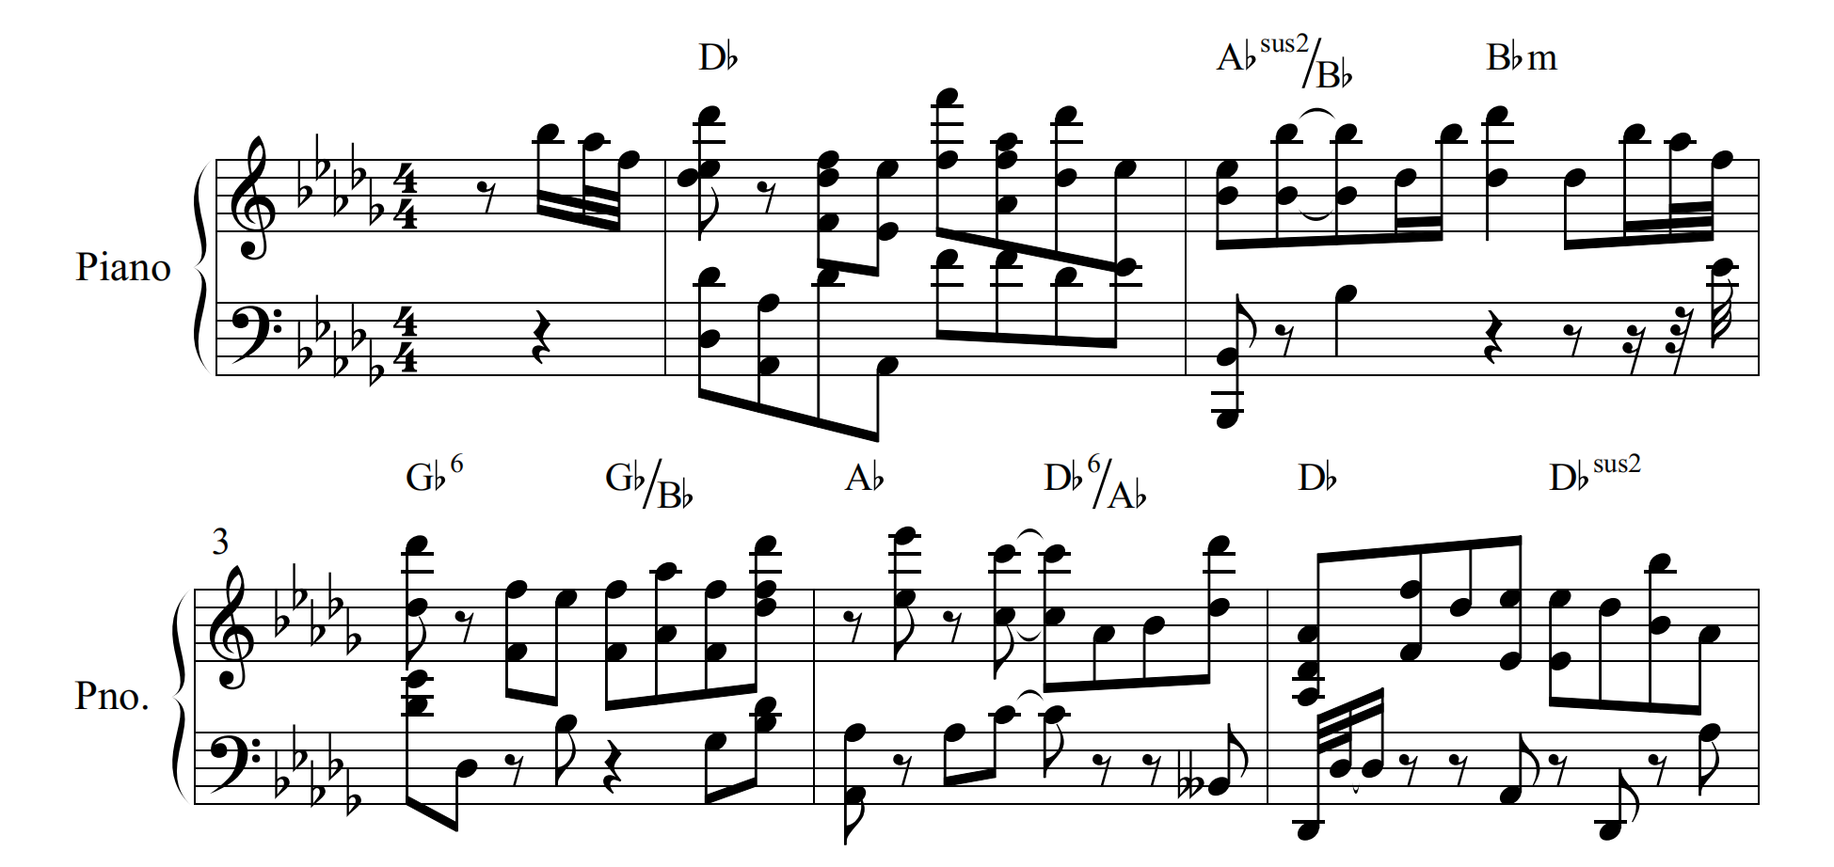
Figure 1. Part of the Song’s Chord Chart
For the evaluation of AI-generated music, subjective evaluation relies on user research, but may result in resource-intensive and inconsistent standards. Objective evaluation (such as model training indicators) lacks musical interpretability and has long lacked unified evaluation standards. This version integrates numerous dramatic elements, combines varying line lengths, and maintains rhyme, reflecting a degree of creativity. Multiple song versions were generated before finalizing a pop style conveying melancholy, using a female vocal. The song, lasting 1 minute and 47 seconds with an 18-second prelude and harmonies, features a powerful and mature vocal with a warbling tone. Doubao did not sing according to the lyrics completely, he skipped some words and changed the order.
The pitch is relatively flat throughout, and although the pitch of the last few sentences is raised, there is no prominent high note. The rhythm is also relatively flat except for the last sentence, and it pays great attention to the words and sentences. The gaps between words and sentences are very short, without the superb singing skills and musical characteristics of Chaoshan opera. There are individual sentences with harmony, which are the last few words of the repeated sentences. However, there is a guzheng performance at the beginning, but the overall sound lacks a certain warmth; although it is clean and skillful, it sometimes seems a bit monotonous and boring compared to the rich changes of live instrumental performance.
Professor Liu Dawei from Shantou University observed that although the song integrates certain melodic elements characteristic of Chaoshan music, its overall melodic structure remains relatively simple. He further noted that while AI systems such as DouBao are capable of generating complete musical compositions, they currently lack the nuanced vocal techniques and expressive qualities essential for effectively engaging listeners. According to Professor Liu, the authentic performance of Chaoshan songs ideally involves the use of the Chaoshan dialect to convey cultural and linguistic specificity—an area where existing AI technologies still face significant limitations.
In conclusion, while DouBao can design lyrics and generate music based on the plot of Chen San and Wu Niang, the music’s quality and appeal require further evaluation. AI is currently more of an auxiliary tool in music creation rather than a means for traditional preservation and passing down. The latest research by Fišer et al. (2025) also shows that people have a stronger preference for music created by humans, but AI-generated music can trigger similar emotional valence as human-created music. In the future, optimizing the prompt word design (such as adding keyword details) can improve the adaptability of AI music.

Table 1. Cultural Feature Mapping in AI-generated Music Based on Chen San and Wu Niang
Dimension | Traditional Chaoshan Opera Music Expression | AI-Generated Music Expression | Cultural Features Present
Singing language & vocal style | Chaoshan dialect, melismatic, winding | Mandarin singing, no traditional vocal technique | No
Instrumentation & arrangement | Wooden clappers, Chaoshan string, flute, gongs and drums | Electronic music with guzheng samples | Partial
Emotional rhythm structure | Large dynamic shifts; combines lyrical slow sections with fast-paced allegro | Uniform rhythm; stable pitch | No
Cultural imagery & lyrics | Uses local imagery (Lantern Festival, mirror grinding) | Includes allusions but lacks rhythmic cohesion | Partial

Chart function description: This table evaluates AI-generated music from a cultural-fidelity perspective rather than technical scoring, examining language, melody, instrumentation, and imagery. It addresses whether AI can substitute traditional musical expression and outlines the boundaries of AI-assisted music creation.

3.2 Comparison of generated images
As Doubao cannot continuously generate a series of comic-like images, this study selects and generates key plots from the 8 scenes of the offline performance of Chen San and Wu Niang. After multiple rounds of image generation, the final image generation prompts for the last round are as follows: “I want to describe some scenes from the first act for AI to generate images. But as AI cannot create comics, I need to break down the first act into several parts. You have outlined the main content of the first act, and now please further divide it into several specific parts for AI image generation, with a focus on cultural elements, including descriptions of costumes.”
This study examines the offline performance of Guangdong Bai Hua Chaoshan Theatre. As Guangdong’s second-batch provincial intangible cultural heritage inheritance base (Liang, 2014), the theatre preserves classic Chaoshan operas like Su Liu Niang and Chen San and Wu Niang, and has created excellent new works such as Sangpu Mountain Flower. Compared to other versions, this version is newer and clearer. Also available on YouTube with 340,000 views, it serves as the research object. In Baihua Chaoshan Theatre’s performance, Wu Niang has 4 costumes, Chen San has 3, and the maid Yichun has 2, while other characters (Lin Da, Li Jie, Huang Jiulang and his wife) have only 1. Doubao has generated the final 8 scenes, each consisting of 3-4 images in cartoon style and a 16:9 aspect ratio, based on prompts created under its deepthinking mode with attention to costume, scene, and action details. Comparing Doubao’s images with screenshots from Baihua Chaoshan Theatre’s offline performance reveals that Doubao falls short in conveying the original plot and cultural meanings in terms of headdress, costumes, shoes, gestures, and scenes.

3.2.1 Chaoshan Opera Helmets and Hair accessories
This study examines character styling, focusing on hairstyles, headwear, and helmets for detailed comparison. Character styling is the first impression of a character’s aesthetics to the audience (Chen, 2010) and symbolizes the character’s identity. Different roles have distinct hairstyles, headwear, and helmets. For instance, Huang Wu Niang, a wealthy young lady, has a Da Hou Wei (大后尾), a complex and ornate hairstyle reflecting her nobility. In contrast, Yi Chun, a maid, has a simpler Diao Tong Zong (吊桶鬃), suiting her role. These hairstyles also reflect personality. For example, the matchmaker Li Jie’s Hou Wei Zai (后尾仔) hairstyle, paired with bright silk flowers and green leaves, shows her passionate and aggressive personality (Chen, 2017). In Chaoshan opera, helmets share a 580-year history (Chen, 2017). Chen San wears a Wen Sheng Jin (文生巾), typical for scholar roles. Lin Da wears a Yuan Wai Jin (员外巾), with its tall cylindrical top and vibrant colors like red and yellow, is designed for wealthy or magistrate characters, highlighting his status (Yang, 2020).
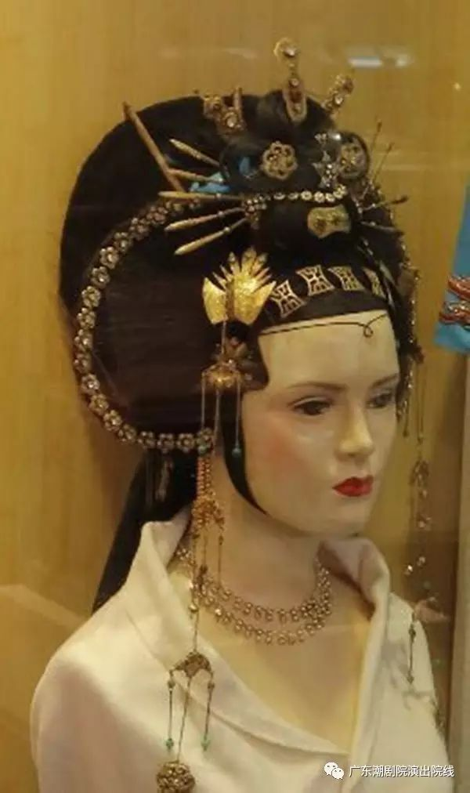 | 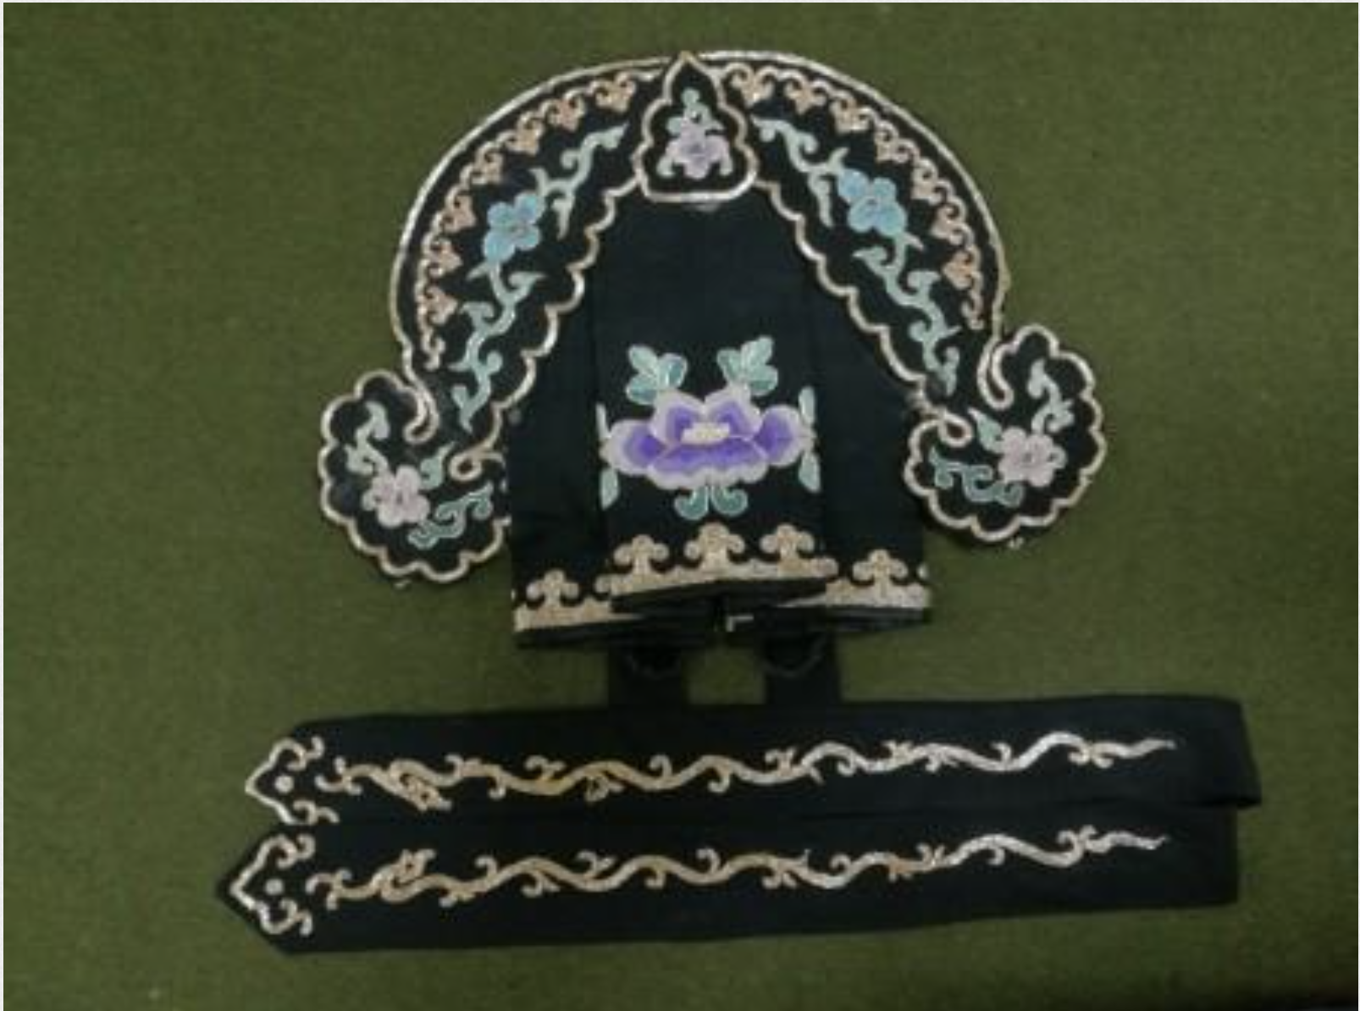 | 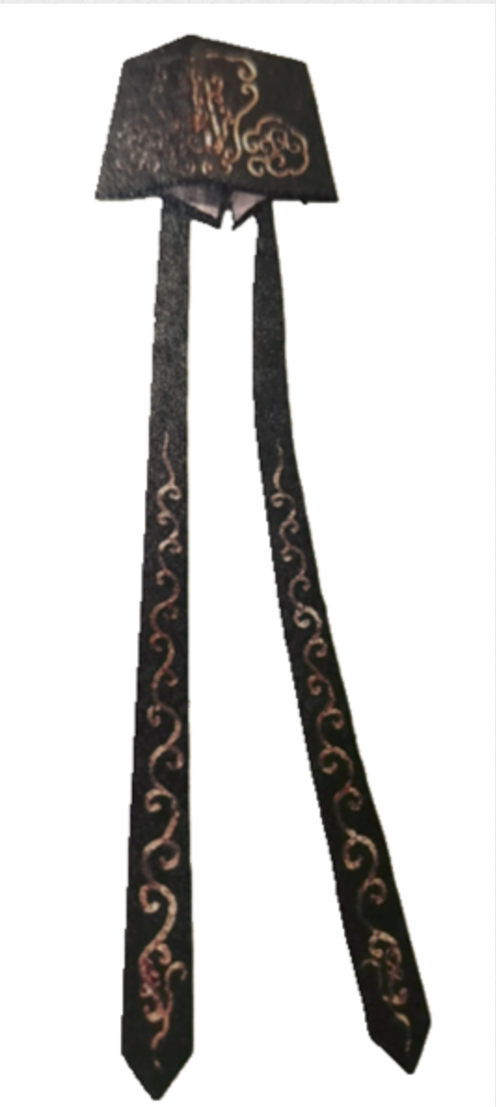
Figure 2. Da Hou Wei | Figure 3. Wen Sheng Jin | Figure 4. Yuan Wai Jin

The first act, “Viewing the Lanterns”, depicts the initial encounter between Chen San and Wu Niang. Chen San, a talent from Quanzhou, meets Huang Wu Niang while seeing his sister-in-law off to Guangnan. Lin Da also encounters Wu Niang and is smitten, requesting a duet with her. As shown in Figure 5, Chen San is in a yellow robe and Wen Sheng Jin with a ruyi pattern (如意纹) and blue tassels. The ruyi pattern, symbolizing good fortune and auspiciousness, reflects his scholarly elegance and carries cultural connotations of blessings. His hair is in a neat topknot with trailing ribbons. As depicted in Figure 6, Wu Niang has a traditional Da Hou Wei hairstyle with phoenix hairpins, red water temples flowers(水鬓花), half-leaf lotuses, and plum blossoms, plus pearl earrings. Water temples flowers, used to decorate the hair temples, reflect the cultural significance of nature and femininity in Chaoshan culture. A red buyao (步摇) is inserted on the side of the bun. Buyao is a kind of jewelry for Han women, which is developed on the basis of hairpins. It is named because it shakes when walking. In Doubao’s generated images, Wu Niang’s features are emphasized with large, singular elements like a golden bu yao, a large fresh flower, and either a golden hua sheng (华胜, a flower shaped jewelry) or a phoenix hairpin., with gold, blue, and white colors echoed in her earrings and topknot (Figure 7, 9, and 18 illustrate these details.). However, Chen San’s depiction is less accurate. His Wen Sheng Jin resembles a traditional scholar’s attire in similar blue, and the headpiece’s front ornament is present.

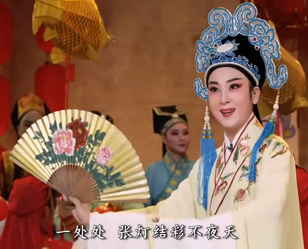 | 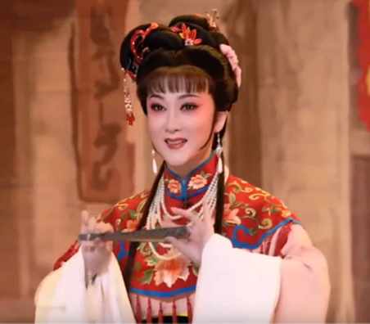
Figure 5. Theatre Edition Chen San Act I | Figure 6. Theatre Edition Wu Niang Act II
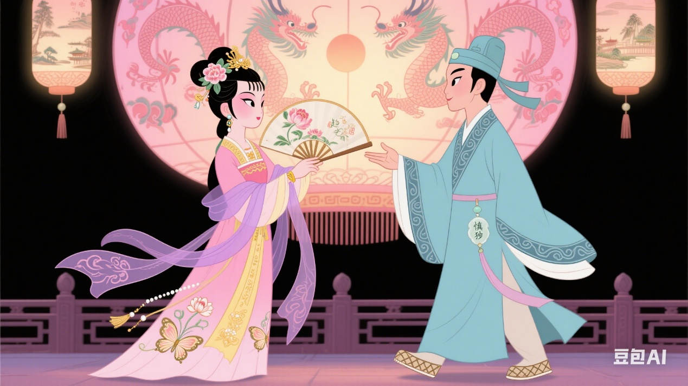
Figure 7. DouBao Edition Chen San and Wu Niang Act I
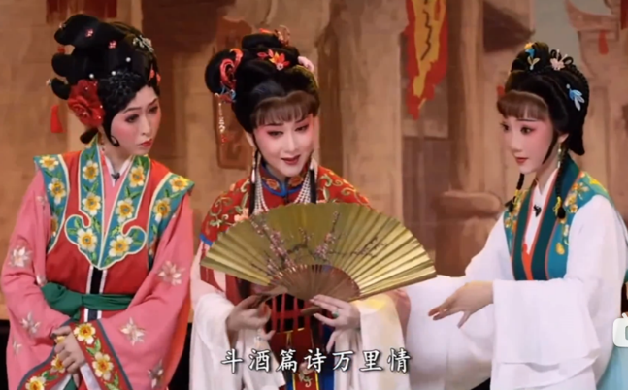 |  | 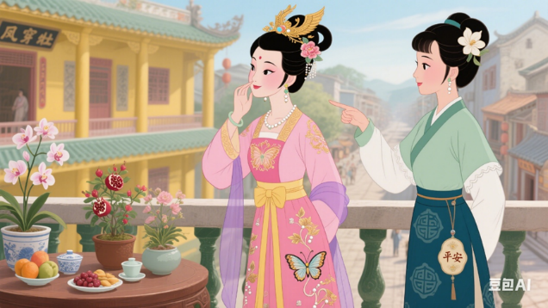
Figure 8. Theatre Edition Li Ji, Wu Niang, and Yi Chun Act I |  | Figure 9. DouBao Edition Wu Niang and Yi Chun Act III
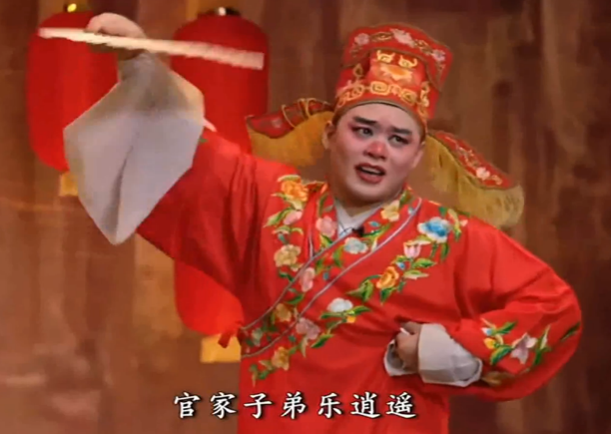 |  | 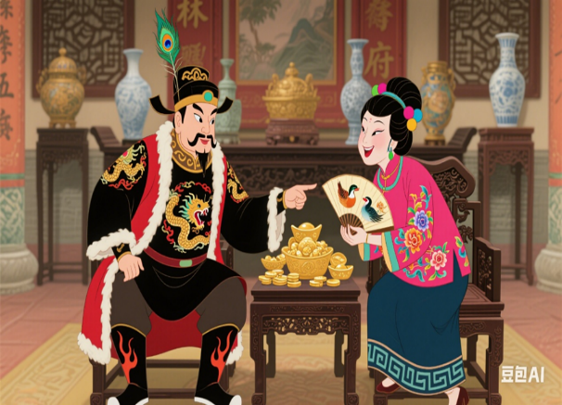
Figure 10. Theatre Edition Lin Da Act I |  | Figure 11. DouBao Edition Li Ji and Lin Da Act II

Act II, “Presenting Bridal Gifts”, shows Li Jie visiting Wu Niang’s home to arrange the marriage on behalf of Lin Da. Unlike Baihua Theatre’s production, Doubao focuses on depicting Yi Chun, Li Jie, and Lin Da in the second and third acts. In the theater production, all characters are in one scene, but Doubao breaks down each character’s actions. Yet, there are still discrepancies in character styling. Yi Chun’s Diao Tong Zong hairstyle, with the top of her head combed into a barrel shape, two short braids hanging down, decorated with colorful velvet flowers and thin buyao, and green earrings, signifies her lively maid status. However, Doubao’s version is simpler, lacking the distinctive cylindrical feature and having only a white flower on top to denote plainness (As shown in Figure 8 and 9).
The outline of Lin Da’s Yuan Wai Jin is generated, but the color is wrong. Lin Da’s is red, which fits his ostentatious clown character. And the exquisite details of the official scarf are not shown. The direction of the hat wings is wrong, it should be downward, but the Doubao version is upward; the hat wings also have some tassels. However, some extra details like peacock feathers and green gems are added. Moreover, Lin Da’s comedic makeup, especially his red nose, is missing, and Doubao erroneously adds a beard, portraying him as a nouveau riche. This contrasts with his dragon- patterned robe, creating an inconsistency (As shown in Figure 10 and 11).
Li Jie, a female clown with exaggerated, humorous actions and rich expressions, has a Hou Wei Zai hairstyle in the drama. This hairstyle features a pagoda-shaped updo with multiple irregularly arranged hair buns of varying sizes and shapes, closely intertwined with a wide, arched hairline. The hair buns extend backward and slightly curve to form a fishtail shape, resembling the letter Y. Her headwear includes diamond-shaped decorations in red and orange, along with blue hairpins. However, Doubao’s generated hairstyle is simplistic, lacking the multi-layered design. It fails to capture the Hou Wei Zai style and lacks the large red flower, replacing it with colorful beads. Yet her eyes are depicted as upturned, long, and thin, effectively conveying Li Jie’s humor. Doubao’s Li Jie in Act II is somewhat different from Act I as shown in Figure 11, 12,13 and 11, showing inconsistencies: her colors are more vibrant, and her hairstyle resembles an official hat rather than the Da Hou Wei style. As for Huang Jiulang, there’s a color difference between the theater and Doubao versions. The theater version features an orange and brown Yuan Wai Jin with rich details of ruyi patterns, while Doubao’s image resembles a scholar’s Black gauze hat (or wusha hat). The two versions portray Huang Jiulang with different personality traits. The Doubao version is simple and kind, but in fact, Huang Jiulang is a bit greedy for money and power, and is a wealthy man from Chaoshan.

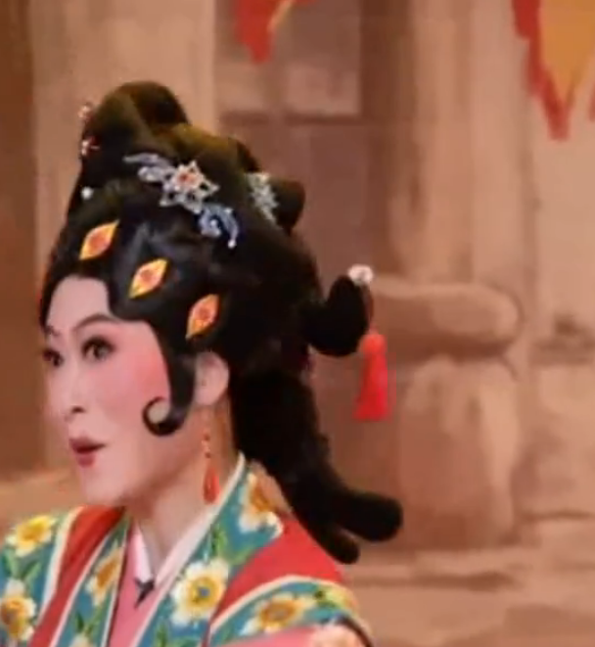 | 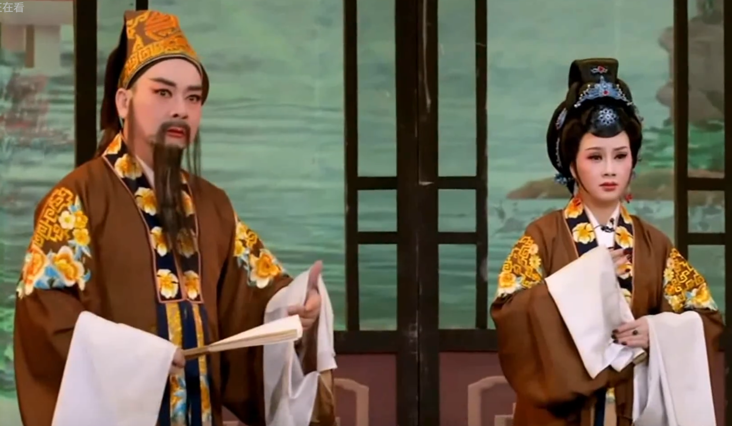 | 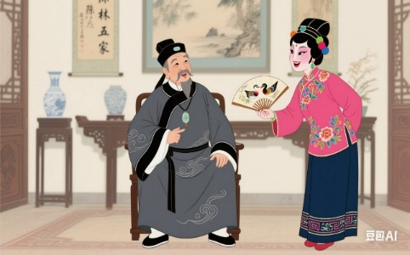
Figure 12. Theatre Edition Li Jie Act I | Figure 13. Theatre Edition Huang Jiu Lang Act II | Figure 14. DouBao Edition Huang Jiu Lang and Li Ji Act II

After comparisons, this study has identified several common issues in the DouBao version of Chen San and Wu Niang that prevent the full display of Chaoshan opera’s unique charm. Some pictures in the DouBao version are unrecognizable as related to the Chen San and Wu Niang. The helmets of male roles are not accurately portrayed, failing to convey the roles’ identities and temperaments. For instance, Chen San’s Wen Sheng Jin is not correctly rendered. The Wen Sheng Jin, a key element in identifying a scholar’s identity in Chaoshan opera, is not reflected in the DouBao version, which weakens Chen San’s refined and elegant image as a scholar. The hairstyles of female roles also differ from the original. In the opera, the hairstyles have clear edges and corners, reflecting the careful character portrayal in Chaoshan opera. However, in the DouBao version, the hairstyles are rounded and wrapped, deviating from the traditional look.
In the theater production, each female character’s hairstyle is meticulously designed. Wu Niang has two Xian Yi Zi (线尾子, the line tail buns) at her temples, created with wig pieces to form long hair strands that fall naturally on the chest, with a long low ponytail at the back. Yi Chun has two short braids in front, with layered hair that is thick at the top and thin at the ends, unlike the uniform thickness shown in Figure 9 or the inverted layering in Figure 19. Li Jie’s hair ends in a fishtail shape. Doubao’s generated images simplify or omit these hairstyles, failing to capture the femininity and liveliness of the characters. Additionally, there are also inconsistencies in the DouBao generation. The presence or absence of bangs in female roles lacks uniformity. This inconsistency affects the overall coherence of the character’s appearance.

Table 2. Comparative Analysis of Character Styling in AI-generated vs. Traditional Theatre Performance
Character | Element Category | Traditional Theatre Features | AI-Generated Version Features |  | Difference Explanation
Wu Niang | Hair accessories | Da Hou Wei; water temples flowers; buyao; pearl |  | Single large flower; gold ornament; phoenix pin | Elements simplified; youthful identity lost
Chen San | Helmet | Wen Sheng Jin; blue tassels; scholarly elegance |  | Simplified cap without tassels | Role identity rendered ambiguous
Li Jie | Hairstyle | Hou Wei Zai; pagoda-shaped bun; red-orange floral headpiece |  | Colored beads; round hair bun | Lacks distinctive flair; character misrepresented
Chart function description: This table compares first-impression styling elements (“hairstyles and headdresses”) across multiple roles, visualizing the contrast between authentic theatre designs and AI outputs. It highlights the AI’s tendency to oversimplify key cultural markers and misinterpret character-specific details, laying the groundwork for a deeper discussion of symbolic accuracy in subsequent sections.

3.2.2 Chaoshan Opera Costumes
Clothing, acting as a second skin, becomes a character interacting with others on stage, helping actors express emotions (Zeng, 2019). As shown in Figure15 and 16, Wu Niang’s costume is a separated top-and-skirt ancient style outfit with a waist cinching design, short water sleeves, and a trailing long skirt. It includes a cloud shoulder (云肩) cape and butterfly styled mid-skirt, typically worn by unmarried girls, fairies, or folk women. From previous images, Wu Niang’s costume is a light-pink ancient style outfit. She wears a red blouse with a pearl chain, a white cloud shoulder cape with rich Chaoshan floral embroidery, and the blouse’s hem also features floral embroidery, looking fresh and elegant. Her lower body has a white underskirt. In Doubao’s version, Wu Niang wears a pink blouse and skirt with gold embroidery, a three-dimensional butterfly embroidered skirt with pearl tassels, a goose yellow palace style sash with a purple gauze cape, and a ruyi pattern. Doubao’s costume is more vibrant, lacking cloud and tassel accessories, with no floral embroidery. It’s a long skirt rather than a separated top-and-skirt outfit and adds butterflies and a purple cape. As Chaoshan embroidery is closely linked to local folk culture, it’s crucial in Chaoshan opera, and AI-generated images should reflect this.
As shown in Figure17 and 18,Chen San wears a Chaoshan opera Xiang shirt (项衫), also known as pleats (褶子) in Peking opera. This garment features a slanting front, a monk collar, wide sleeves, and extends to the ankles. It is commonly referred to as an embroidered Xiang shirt and is worn by Chen San throughout the play. In the first scene, his Xiang shirt is yellow, adorned with floral embroidery on the collar and body, featuring wide sleeves with white water sleeves at the cuffs. In Doubao’s version, Chen San’s Xiang shirt is blue, lacking floral embroidery and replaced with ruyi patterns. Additionally, Doubao’s version includes a belt and jade pendant not present in the original design. In the fourth scene, “Mirror-Grinding,” Chen San disguises himself as a mirror grinder to infiltrate the Huang residence. In the theater production, he wears a dark blue headcloth, with his hair simply tied up. He dons a Chaoshan opera Xiang shirt Dust Pants (项衫尘裤), a short jacket and pants, specifically a short-style informal garment typically worn by laborers in Chaoshan opera. His outfit consists of a light blue short jacket with simple floral embroidery on the front and cuffs, a red fabric sash with patterns at the waist, and loose dark blue trousers. The cuffs are widened for aesthetic purposes. In Doubao’s version, Chen San’s outfit is in brown, gray, and black tones. The collar and sash lack Chaoshan embroidery patterns, and the sash is made of cloth rather than silk. He also wears a tattered apron, and his short - jacket sleeves are rolled up for labor, eliminating the water sleeve design. Overall, Doubao’s version presents Chen San in an ordinary servant’s attire, lacking the theatrical charm of the traditional design.
The maid Yi Chun wore a Colorful clothes and pants (彩色衣衫裤or彩罗衣衫裤) as shown in Figure17 and 18,. This outfit features a large lapel, small standing-collar design, with a short, narrow sleeved jacket paired with Chinese-style trousers. Yi Chun’s jacket is a layered ensemble of navy, lake blue, orange, yellow, and white, embroidered with large yellow flowers. A yellow embroidered sash cinches the waist, adorned with two dark green vertical decorative strips in the center. Her lower body is dressed in a green gradient skirt with floral embroidery, creating an overall light and airy feel. In Doubao’s version, Yi Chun’s colors are predominantly green and white. The clothing decorations are minimal, replacing floral embroidery with peace-and-fortune motifs, and the yellow embroidered sash is absent. The water sleeves are replaced with tight-fitting sleeves akin to those on a modern shirt.
Overall, AI-generated costumes in Chaoshan opera lack the distinctive features of this drama style and more closely resemble ancient and modern costumes in contemporary TV series. For example, Fan Bingbing's well-known drama The Empress of China has a typical chest-length skirt style, which is very similar to the image of Wu Niang created by Doubao. Elements like butterflies, bows, shirt sleeves, and capes in Doubao’s images are common in modern times but not typical of Chaoshan opera, indicating that Doubao fails to grasp the beauty of Chaoshan opera. Although Chen San disguises himself as a mirror grinder, as the leading actor, he should not wear the same clothes as ordinary servants. However, Doubao generates images of him in ordinary laborers’ clothing. The costumes of Yi Chun, the maid, also have unique features, but Doubao’s images fail to capture these details adequately.

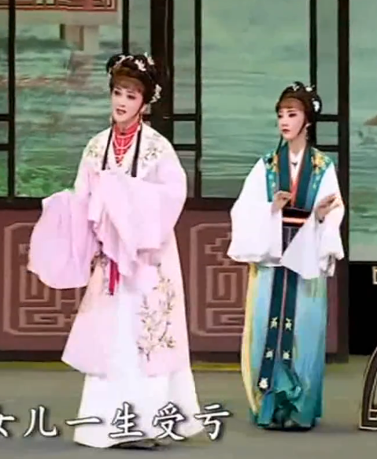 | 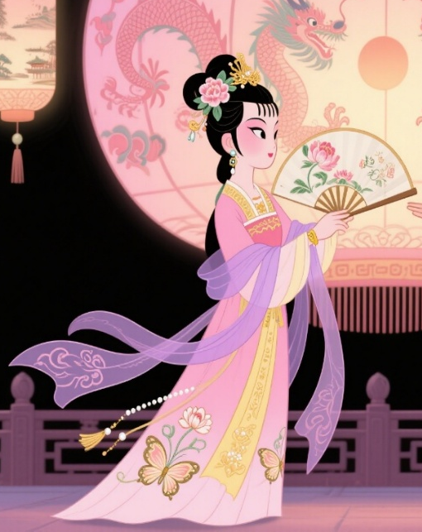
Figure 15. Theatre Edition Wu Niang and Yi Chun Act II | Figure 16. DouBao Edition Wu Niang Act I
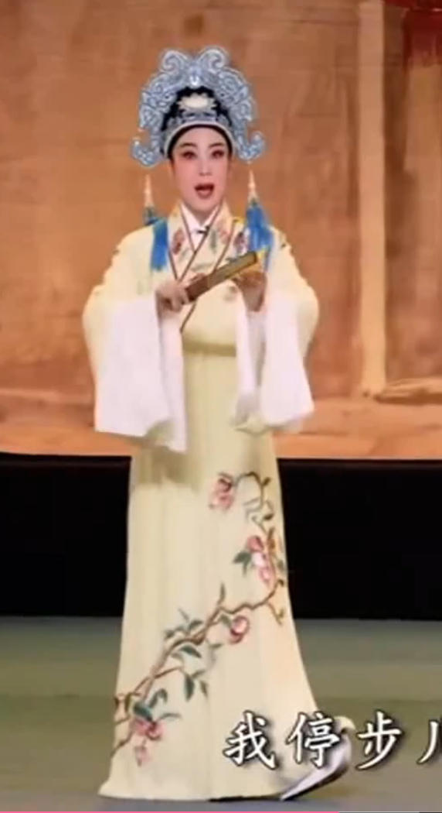 | 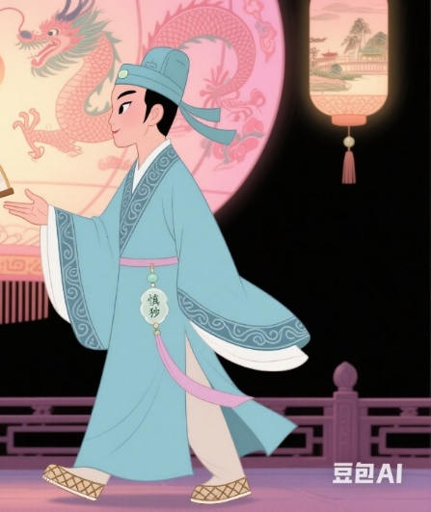
Figure 17. Theatre Edition Chen San Act I | Figure 18. DouBao Edition Chen San Act I
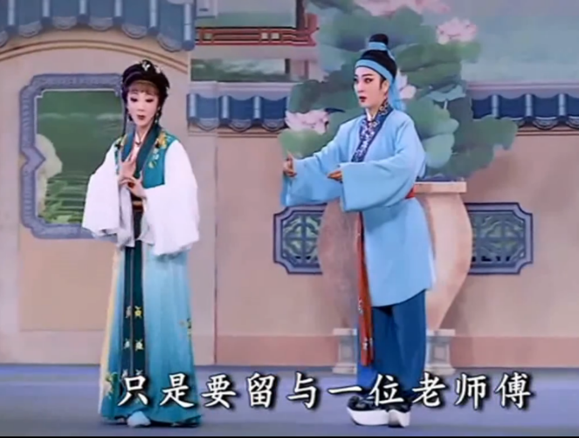 | 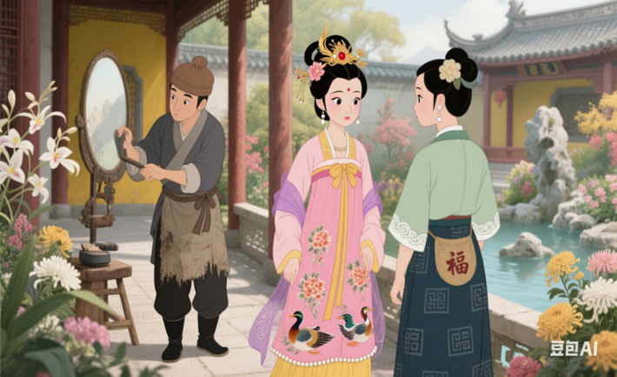
Figure 19. Theatre Edition Chen San Act IV | Figure 20. DouBao Edition Chen San, Wu Niang, and Yi Chun Act IV

3.2.3 Chaoshan Opera Shoes
Traditional Chinese opera shoes, including boots (靴) , footwears (履) and shoes (鞋), reflect traditional aesthetics and craftsmanship（Li, 2023）. They are rooted in everyday life but with enhanced artistic features. In Chaoshan opera, female characters’ shoes are usually concealed by long skirts and small steps, making them hard to see. These shoes are typically embroidered and match the outfit. Wu Niang and Yi Chun wear tasseled embroidered shoes (缀穗绣花鞋) similar to the pointed-toe “colorful shoes” in Peking opera, with multicolored tassels (五色穗子) at the toe. In Doubao-generated images, Wu Niang and Yi Chun’s shoes lack visible tassels. Li Jie’s lively personality suggests she wears red embroidered flat shoes with floral patterns. However, Doubao’s Li Jie wears plain single-colored women’s shoes with no embroidery, appearing thin and flat, and her shoes sometimes reveal more skin or are not shown at all (Figure 21, 22, 23 and 24 illustrate these details.).
In Chaoshan opera, male characters typically wear boots or footwears. Male characters’ shoes in Chaoshan opera are divided into high-soled boots for prominent figures and flat boots for commoners. Chen San wears white high-soled boots with a white sole, black satin upper, and white hook patterns. Other male characters also wear high-soled shoes matching their personalities. Although Doubao-generated male boots are slightly taller, they still fail to accurately represent high-soled boots and exhibit a lack of variety and detail, indicating that AI tends to neglect footwear in image generation (Figure 25 and 26 illustrate these details.).

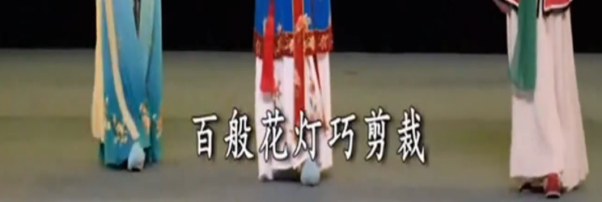 | 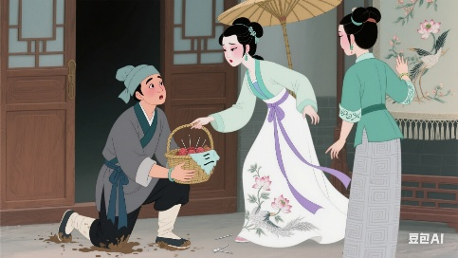
Figure 21. Theatre Edition Yi Chun, Wu Niang and Li Jie | Figure 22. DouBao Edition Chen San, Wu Niang and Yi Chun
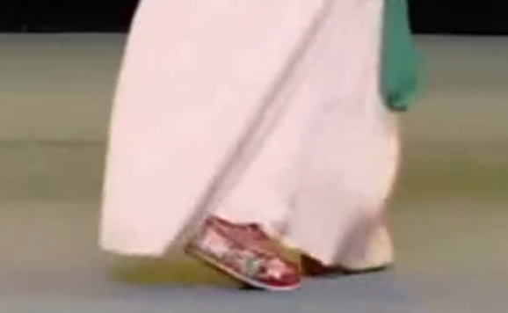 | 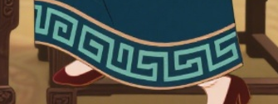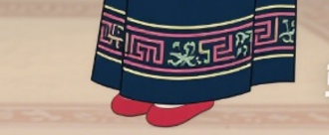
Figure 23. Theatre Edition Li Jie | Figure 24. DouBao Edition Li Jie
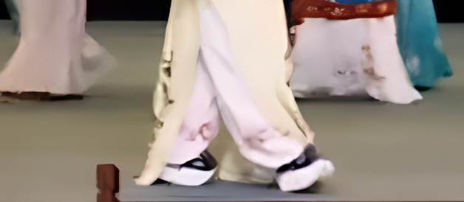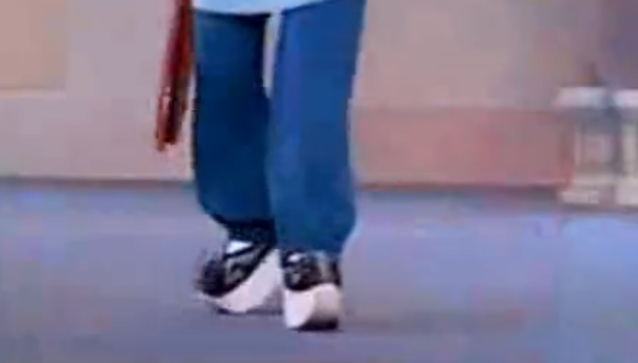 | 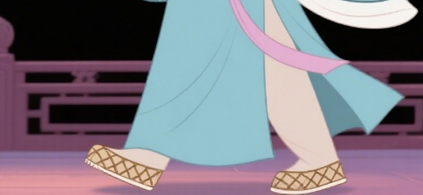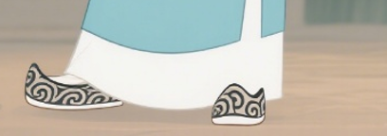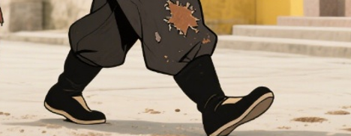
Figure 25. Theatre Edition Chen San | Figure 26. DouBao Edition Chen San

Table 3. Fidelity of Key Cultural Elements in AI-generated Visuals Compared to Traditional Performance
Cultural Element | Original Function in Opera | AI-Generated Presentation | Function Realized? | Explanation
Water sleeves (Costume) | Convey character emotion and rhythmic movement | Some characters lack any water sleeves | No | Loses dynamic aesthetics and on-stage tension
Cloud shoulder/ Collar | Ming-dynasty women’s formal attire element, status symbol | Rendered as chest-skirt style with low neckline | No | Misplaces historical era and social hierarchy
Dragon motif (pattern) | Reserved for royalty, symbolizes power | Applied to commoner roles (e.g., Lin Da) | No | Symbol misused; cultural misinterpretation
High-soled boots (Men’s shoes) | Distinguish social rank; support stable performance posture | Replaced by flat cloth shoes or modern styles | No | Lacks functional support and regional specificity

Chart function description: This table highlights core intangible-heritage visual elements that AI tools fail to restore accurately, reinforcing the critique of cultural accuracy and supporting the recommendation that future AI improvements must address cultural function and semantic understanding.

3.3 Importance of Cultural Accuracy in Chaoshan Opera
Chaoshan opera has a distinctive identity with unique performance styles, music, costumes, and stage aesthetics. However, AI-generated images often fail to capture these unique elements accurately. These elements cannot be ignored, and this article will continue to discuss the importance of these elements.

3.3.1 Chaoshan Opera Helmets and Hair Accessories
In Chinese culture, hair holds profound significance. It is not only a vital aspect of personal adornment but also embodies rich folk beliefs and cultural connotations. Thus, hair protection is emphasized at every life stage—from the careful preservation of a newborn’s first cut hair to the tradition of gifting locks of hair as tokens of love in adulthood. The Classic of Filial Piety states: “One’s body, hair, and skin are bestowed by one’s parents; one dare not damage them,” linking hair to Confucian ethics (Shu, 2004). Consequently, both men and women in ancient China grew long hair, differing only in styling: men typically bound their hair atop the head with caps, while women fashioned elaborate buns (Song, 2002). According to Han tradition, girls underwent the hair-pinning ceremony at age 15, marking adulthood by coiling hair into a bun secured with hairpins.
Hair length and thickness were key measures of female beauty (Song, 2002). To meet aesthetic standards, women often augmented their hair with extensions or wore ceremonial hairpieces. Aristocratic women grew long hair, styled high buns, and wore ornate hairpieces, while commoners wore shoulder-length hair in simple low buns or ponytails. In the Chaoshan opera Chen San and Wu Niang, this hierarchy is reflected: Wu Niang, a noble daughter, has intricate long hairstyles, her maid Yichun sports shorter practical styles, and the matchmaker Li Jie’s hair is modestly adorned. However, AI-generated images simplify these distinctions, rendering hairstyles nearly identical and erasing critical class cues.
Traditional Chinese opera headwear, or “Tou Mian (头面),” is categorized into soft and hard types. Soft headwear—hair nets, padding, and simple pins—establish foundational looks. Hard headwear, such as jewel-embedded is more ornate and signifies a character’s status and personality through decorations like jewels, velvet balls, and tassels (Cheng, 2024). Doubao-generated images predominantly feature incorrect and simplified headwear, reducing the original variety to one or two types. In Doubao’s version, Wu Niang and Yi Chun wear a single flower instead of the colorful velvet hair blooms, water temples flowers, half-lilies, and plum granules typically used as hair decorations. Fresh flowers, being perishable, are rarely used in operas. These hair ornaments also symbolize social status; for example, blue dotted with velvet flowers require dye from hundreds of kingfishers (exclusive to the queen), pink velvet peony flowers on a flower-maiden’s temples denote youthful charm, and silver-gray implies poverty. A single flower lacks these cultural connotations, appearing overly plain and reducing the perceived status of the character. Doubao’s version also adds a large phoenix hairpin to Wu Niang, which is inconsistent with her character. As a young lady from a wealthy family, she would not wear phoenixes or golden ornaments, which symbolize power, wealth, and status and are typically reserved for weddings.

3.3.2 Chaoshan Opera Costumes
In Chaoshan opera, costumes are predominantly based on Ming-dynasty clothing, reflecting the periods commonly depicted in the plays and incorporating the dress characteristics of the relevant era (Yu, 2013). Chen San and Wu Niang, originating in the Ming dynasty (1368-1644), diverges from the open-minded fashion of the Tang period (618-907). Judging from the Ming Dynasty women’s shirts unearthed in Jiangxi Province, most of the Ming Dynasty women’s shirts had stand-up collars and double-breasted collars, and the necklines were relatively small (Ding & Wang, 2019). Unlike the high-necked, crossed-collar, or cloud-shoulder designs typical of the stage, Doubao-generated images show Wu Niang with an empty neckline. This resembles the wide-sleeved blouses and skirts of the Wei and Jin dynasties and the Tang-dynasty chest-aligned skirts. However, such designs conflict with the Ming-dynasty origins of Chen San and Wu Niang.
In Chaoshan opera costumes, elements like embroidery are as important as the fit. Chaoshan embroidery is known for its balanced and full composition, rich colors, and fine stitching. In Doubao-generated images, Wu Niang’s clothes feature butterflies, flowers, and geese, while in the theater production, they are embroidered with various flowers typical of Chaoshan embroidery. For example, Figure6 shows peonies on Wu Niang’s outfit, symbolizing wealth and nobility (Chiem, 2017), fitting for her elaborate lantern festival attire. In contrast, Doubao’s versions of Chen San, Yi Chun, and Huang Jiulang only have ruyi patterns and lack other designs. In reality, their costumes should also be richly embroidered with flowers. For instance, scholars’ robes are embroidered with the “Four Gentlemen” (plum, orchid, bamboo, and chrysanthemum), reflecting Zhu Xi’s Neo-Confucian idea of “understanding things to gain wisdom,” which personifies plants. Lin Da’s costume, however, is wrongly embroidered with dragons and flames. Dragons, as a national totem and symbol of royal power (Czirakova, 2023), are not appropriate for Lin Da, a wealthy commoner, as dragon patterns are reserved for the imperial family. In Chaoshan embroidery, flowers are densely embroidered with lush branches and leaves, in a layered way. The bottom layer is dark green leaves, the middle layer light green new leaves, and the top layer flowers. This mimics real plant layers and shows the high - level skill of Chaoshan embroidery.
Water sleeves, white silk strips sewn onto the cuffs of opera costumes like pleats, capes, robes, and official garments (Zhu, 2019), are so named because they resemble water ripples when actors wave them. They enhance dancers’ grace and express characters’ demeanor, momentum, and emotions through movements like shaking, throwing, waving, and flicking sleeves. For instance, Wu Niang’s pink water sleeves in Figure 15 accentuate her image. In Act Four, during a trio singing scene where the characters question why Chen San is in the Huang residence, Wu Niang’s agile movements and pink water sleeves create a vivid, peach-blossom-like effect, dancing with varying speeds and forces. However, not all characters have water sleeves: Li Jie and Chen San as a mirror grinder do not. Yet, Doubao fails to generate water sleeves for characters that should have them, which needs improvement.

3.3.3 Chaoshan Opera Shoes
In Chaoshan opera, male roles, in particular the Sheng (生角), typically wear thick -soled boots, while female roles (Dan旦角) wear colorful shoes. The scholar (Zhu, 2019) believe that thick-soled boots were invented by Chen Mingzhi, a “village clown” during Emperor Kangxi Period, Qing Dynasty (1662-1722). Originally from northern China, thick-soled boots were first adopted by northern nobles, especially officials, to cope with the cold winters and warm springs. This practical design gradually became a symbol of status due to its “majestic and solemn” appearance and was incorporated into the Qing-dynasty official clothing system. In traditional theater, where female actors often played male roles, thick-soled boots helped increase height, preventing actors from appearing shorter than female characters on stage and emphasizing gender and status differences. For example, Huang Baoqi, a female actor playing Chen San, would wear thick-soled boots. The black- and-white-colored boots, with large-area black satin uppers and white thick soles, make the character look taller. Also, thick soles balance the visual effect with wide helmets and costumes. However, Doubao-generated images fail to reflect this, showing male characters in flat or cloth shoes instead of thick-soled boots.
Moreover, one type of shoe generated for Chen San (the second one in Figure 26) is the upturned-toe shoe, characterized by its upturned toe. Upturned-toe shoes were popular from the Wei and Jin to the Sui and Tang dynasties. However, by the Ming dynasty, high -headed upturned-toe shoes for women were rare. In the Qing dynasty, foot-binding became more prevalent among the common people, reaching its historical peak, and embroidered small-foot shoes became the main footwear for women, causing the upturned-toe feature to disappear. Since Chen San and Wu Niang is set in the Ming and Qing period, upturned-toe shoes are historically inaccurate for this story.

4. Conclusion
A Chaoshan opera is actually a comprehensive interpretation of Chsaoshan music, Chaoshan tunes and many types of Chaoshan craftsmanship. The integration and interaction is the most local artistic symbol. The various elements in Chaoshan opera are coordinated and integrated, from head to toe, that is, helmets, hair accessories, clothes and shoes, etc., must echo each other. This study utilized Doubao’s artistic generation capabilities to create music and produce multiple images based on the Guangdong Baihuayuan Theatre production of Chen San and Wu Niang, exploring the application of AI-generated art in promoting Chaoshan opera culture. By evaluating the music and comparing the character styling, costumes, and footwear from Doubao and the theater production, the study concluded that AI currently has significant limitations in generating regionally accurate music and requires enhancements in the realism and artistry of its visual outputs. The study also highlighted the importance and cultural significance of Chaoshan opera elements, emphasizing that these should be prioritized in future AI-generated content.
AI-generated art offers hope for cultural promotion but has limitations. Its ability to capture complex cultural differences is restricted by the quality and specificity of input instructions. Current AI models also cannot fully replicate the emotional depth and artistic style of traditional performances. The study’s limitation is that it did not explore the impact of generated images. Future research could compare different AI platforms and collaborate with dramatists to generate more authentic and emotionally resonant cultural works.

Ethical Statement
This study does not contain any studies with human or animal subjects performed by any of the authors.
Conflicts of Interest
The authors declare that they have no conflicts of interest to this work.
Author Contribution Statement
Author 1: Writing guidance & writing review and editing.
Author 2: Conceptualization, data Curation, formal analysis..
Data Availability Statement
Data sharing is not applicable to this article as no new data were created or analyzed in this study.
References
- Andreescu, R.-C., & Ratiu, D.-E. (2023). Art in the time of AI: Style and artistic intention in AI-generated images. Meta: Research in Hermeneutics, Phenomenology, and Practical Philosophy, 15(2), 415-451.
- Arkhipova, D., & Vidalepp, A. (2023). Lotman’s semiotics of culture in the age of AI: Analyzing the cultural dynamics of AI-generated video art in the semiosphere. Semiotica, 2023(255), 149-160. https://doi.org/10.1515/sem-2023-0167
- Arriagada, L. (2025). Defining an AI-generated artwork: A transdisciplinary concept for cognitive science, computer science, and art theory. Calle 14: Revista de Investigación en el Campo del Arte, 20(38), 95-108. https://doi.org/10.14483/21450706.22275
- Aziz, M., Rehman, U., Danish, M. U., Ali, S., & Abbasi, A. Z. (2025). Towards a unified evaluation framework: Integrating human perception and metrics for AI-generated images. Multimedia Systems, 31(2), Article 180. https://doi.org/10.1007/s00530-025-01769-7
- Bara, I., Ramsey, R., & Cross, E. S. (2025). AI contextual information shapes moral and aesthetic judgments of AI-generated visual art. Cognition, 257, 106063. https://doi.org/10.1016/j.cognition.2025.106063
- Bougueffa, H., Keita, M., Hamidouche, W., Taleb-Ahmed, A., Liz-López, H., Martin, A., Camacho, D., & Hadid, A. (2024). Advances in AI-generated images and videos. International Journal of Interactive Multimedia and Artificial Intelligence, 9(1). https://doi.org/10.9781/ijimai.2024.11.003
- Civit, M., Civit-Masot, J., Cuadrado, F., & Escalona, M. J. (2022). A systematic review of artificial intelligence-based music generation: Scope, applications, and future trends. Expert Systems with Applications, 209, Article 118190. https://doi.org/10.1016/j.eswa.2022.118190
- Civit, M., Drai-Zerbib, V., Lizcano, D., & Escalona, M. J. (2024). SunoCaps: A novel dataset of text-prompt–based AI-generated music with emotion annotations. Data in Brief, 55, Article 110743. https://doi.org/10.1016/j.dib.2024.110743
- Cheng, C. H. (2024). Analysis of headwear modeling design on the opera stage. Drama Home, (35), 55-57.
- Chen, D. H. (2010). Headdresses and character modeling: A brief discussion on the evolution of character modeling in Liyuan opera Chen and San Wu Niang. Literary Circle (Theoretical Edition), (5), 218.
- Chen, J. J., House, J., & Kádár, D. Z. (2025). Chinese “face”-related expressions in Peking and Teochew Opera scripts. Journal of Historical Pragmatics, 26(2), 175-205. https://doi.org/10.1075/jhp.23020.che
- Chen, W. (2017, June 26). Ingenious art of Chaoshan opera headdresses. Shantou Special Economic Zone Evening News website. https://www.gdcjy.com/index/article/detail.html?id=998
- Chen, Y. Q. (2011). Ideological connotations of Li Jing Ji and the evolution of the Chen San and Wu Niang. Journal of Quanzhou Normal University, 29(1), 7-14. https://doi.org/10.16125/j.cnki.1009-8224.2011.01.002
- Chiem, K. (2017). Painting, peonies, and Ming loyalism in Qing-dynasty China, 1644-1795. Archives of Asian Art, 67(1), 83-109. https://doi.org/10.1215/00666637-3788654
- Czirakova, D. Z. (2023). Descendants of the dragon: The dragon as a symbol of Chinese national identity. Asian and African Studies, 32(1), 60-82. https://doi.org/10.31577/aassav.2023.32.1.04
- de Aguiar, V. (2024). Music and affectivity in the age of artificial intelligence. Topoi: An International Review of Philosophy, 43(3), 725-735. https://doi.org/10.1007/s11245-024-10050-x
- Ding, P. L., & Wang, Y. R. (2019). Fashion evolution of Ming dynasty women’s jackets: Based on an unearthed Sihe Ruyi dark-flower cloud-pattern women’s jacket. Southern Cultural Relics, (2), 259-269.
- Entropy and complexity analysis of AI-generated and human-made paintings. (2023). Chaos, Solitons & Fractals, 170, Article 113385. https://doi.org/10.1016/j.chaos.2023.113385
- Fišer, N., Martín-Pascual, M. Á., & Andreu-Sánchez, C. (2025). Emotional impact of AI-generated vs. human-composed music in audiovisual media: A biometric and self-report study. PLOS ONE, 20(6), Article e0326498. https://doi.org/10.1371/journal.pone.0326498
- Gîrbaccia, F. (2024). An analysis of research trends for using artificial intelligence in cultural heritage. Electronics, 13(18), 3738. https://doi.org/10.3390/electronics13183738
- Grassini, S. (2025). Computational power and subjective quality of AI-generated outputs: The case of aesthetic judgement and positive emotions in AI-generated art. International Journal of Human-Computer Interaction, 41(14), 9056-9065. https://doi.org/10.1080/10447318.2024.2422755
- Heigl, R. (2025). Generative artificial intelligence in creative contexts: A systematic review and future research agenda. Management Review Quarterly. Advance online publication. https://doi.org/10.1007/s11301-025-00494-9
- Hitsuwari, J., Ueda, Y., Yun, W. J., & Nomura, M. (2023). Does human-AI collaboration lead to more creative art? Aesthetic evaluation of human-made and AI-generated haiku poetry. Computers in Human Behavior, 139, Article 107502. https://doi.org/10.1016/j.chb.2022.107502
- Hou, Y. M., Kenderdine, S., Picca, D., Egloff, M., & Adamou, A. (2022). Digitizing intangible cultural heritage embodied: State of the art. ACM Journal on Computing and Cultural Heritage, 15(3), Article 55. https://doi.org/10.1145/3494837
- Li, C. (2023). Research on the artistic features of traditional Henan opera shoes. West Leather, 45(19), 124–127. https://doi.org/10.20143/j.1671-1602.2023.19.037
- Liang, Q. (2014, December 31). Guangdong Provincial Department of Culture on the display of the second batch of provincial cultural ecological protection pilot zones and intangible cultural heritage inheritance base selected lists announcement. Guangdong Provincial Department of Culture and Tourism. https://whly.gd.gov.cn/open_newggl/content/post_2798598.html
- Liu, F. L. (2019). The musical evolution of singing styles from the Jiajing edition of Li Jing Ji to the Chao opera Chen San and Wu Niang. Music Communication, (Z1), 82-91, 124.
- Lin, L. (2019). Development status and countermeasure suggestions for Chaoshan opera in the Chaozhou region. Voice of the Yellow River, (8), 21. https://doi.org/10.19340/j.cnki.hhzs.2019.08.012
- Lu, Y., Wu, J. C., Wang, M. Y., Fu, J. Y., & Xie, W. X. (2025). Design transformation pathways for AI-generated images in Chinese traditional architecture. Electronics, 14(2), Article 282. https://doi.org/10.3390/electronics14020282
- Messingschlager, T. V., & Appel, M. (2025). Mind ascribed to AI and the appreciation of AI-generated art. New Media & Society, 27(3), 1673-1692. https://doi.org/10.1177/14614448231200248
- Milasan, L. H. (2024). Unveiling the transformative potential of AI-generated imagery in enriching mental health research. Qualitative Health Research. Advance online publication. https://doi.org/10.1177/10497323241274767
- Ng, N. (2021). Engaging with a genre in decline: Teochew Opera in Western Sydney. Asia Pacific Journal of Anthropology, 22(2-3), 162-183. https://doi.org/10.1080/14442213.2021.1923794
- Oppenlaender, J. (2024). A taxonomy of prompt modifiers for text-to-image generation. Behaviour & Information Technology, 43(15), 3763-3776. https://doi.org/10.1080/0144929X.2023.2286532
- Shu, D. G. (2004). A study of the title of the Xiaojing and its compilation period. Journal of Xihua University (Philosophy and Social Sciences Edition), (1), 38-42, 80. https://doi.org/10.19642/j.issn.1672-8505.2004.01.012
- Skiljic, A. (2021). When art meets technology or vice versa: Key challenges at the crossroads of AI-generated artworks and copyright law. IIC—International Review of Intellectual Property and Competition Law, 52(10), 1338-1369. https://doi.org/10.1007/s40319-021-01119-w
- Song, J. H. (2002). A study on the Chinese ancient theatrical costume Chinese Classical literature (Doctoral dissertation, Sun Yat-sen University). https://kns.cnki.net/kcms2/article/abstract?v=GQPEaosfmU-pvOHqvr8mP-ut5t6gBZTOlfJ1iRI5E-SWJs0URlO0EUo24UABilsNshlCNvrlwpqym3Dsb6dhlZ3Ep0pGmpjKPo-sBUTKFLSz8VM-S3mNOJNbzPb72YcfDYrH0ZxvHqJAVOs2v0ceT_pKcMAldyV8EGzfDQCpwPp0FyDF7EQvnLfXz3i7enod&uniplatform=NZKPT&language=CHS
- State Council of the People’s Republic of China. (2006). Notice of the State Council on publishing the first batch of the national intangible cultural heritage list. Official Gazette of the State Council of the People’s Republic of China, (20), 8-24.
- Stright, A., Sloan, G., Code, M., Gorman, M., Moss, R., & Mcsweeney, M. B. (2025). A preliminary investigation into the use of AI-generated food images in a survey asking about consumer perception of appeal, naturalness, healthiness, and willingness to consume. Journal of Sensory Studies, 40(1), e70015. https://doi.org/10.1111/joss.70015
- Su, Z. Y. (2025). Inheriting cultural heritage: The application of virtual reality technology in the display of Peking Opera costumes. IEEE Access, 13, 107832-107843. https://doi.org/10.1109/ACCESS.2025.3572446
- Temsah, M.-H., Alhuzaimi, A. N., Almansour, M., Aljamaan, F., Alhasan, K., Batarfi, M. A., Altamimi, I., Alharbi, A., Alsuhaibani, A. A., & Alwakeel, L. (2024). Art or artifact: Evaluating the accuracy, appeal, and educational value of AI-generated imagery in DALL·E 3 for illustrating congenital heart diseases. Journal of Medical Systems, 48(1), Article 54. https://doi.org/10.1007/s10916-024-02072-0
- Tsatsanashvili, A. (2024). Artificial intelligence in the protection of intangible cultural heritage. European Journal of Transformation Studies, 12(1).
- Tu, X. H. (2014). A comparative analysis of the Jiajing edition of Li Jing Ji and the Wanli edition of Li Zhi Ji: The classic text of the Chen San and Wu Niang. Journal of Fujian Normal University (Philosophy and Social Sciences Edition), (6), 55–60, 66.
- Vila, L. C., Sturm, B. L. T., Casini, L., & Dalmazzo, D. (2025). The AI music arms race: On the detection of AI-generated music. Transactions of the International Society for Music Information Retrieval, 8(1), 179-194. https://doi.org/10.5334/tismir.254
- Wasielewski, A. (2024). Unnatural images: On AI-generated photographs. Critical Inquiry, 51(1), 1–29. https://doi.org/10.1086/731729
- Wang, Y. D., & Zhou, Y. X. (2025). Artificial intelligence-driven interactive experience for intangible cultural heritage: Sustainable innovation of Blue Clamp-Resist Dyeing. Sustainability, 17(3), Article 898. https://doi.org/10.3390/su17030898
- Xu, Y. L. (2016). A study on the dissemination impact of the Chao opera Chen San and Wu Niang. Journal of Shantou University (Humanities and Social Sciences Edition), 32(1), 26-32, 94.
- Yang, Y. (2025). Racial bias in AI-generated images. AI & Society. https://doi.org/10.1007/s00146-025-02282-1
- Yu, Y. (2013). Application of Tang dynasty women’s costumes in Chaozhou opera costumes. Art Education, (4), 124-125.
- Zeng, Y. N. (2019). An analysis of aesthetic elements under modern consciousness in the Chaoshan opera stage: An overview of costume design for the Chaoshan opera Li Shangyin. China Drama, (6), 84-86.
- Zhao, J. X. (2024). Digital protection and inheritance path of intangible cultural heritage based on image processing algorithm. Scalable Computing: Practice and Experience, 25(6), 4720–4728. https://doi.org/10.12694/scpe.v25i6.3287
- Zhang, B., Cheng, P., Deng, L., Romainoor, N. H., Han, J., Luo, G., & Gao, T. (2023). Can AI-generated art stimulate the sustainability of intangible cultural heritage? A quantitative research on cultural and creative products of New Year Prints generated by AI. Heliyon, 9(9), Article e20477. https://doi.org/10.1016/j.heliyon.2023.e20477
- Zhang, J. K., & Jing, Y. H. (2022). Application of artificial intelligence technology in cross-cultural communication of intangible cultural heritage. Mathematical Problems in Engineering, 2022, Article 6563114. https://doi.org/10.1155/2022/6563114
- Zhou, T. W., Tan, S. B., Li, L. D., & Zhao, B. Q. (2025). Cross-modality interactive attention network for AI-generated image quality assessment. Pattern Recognition, 167, Article 111693. https://doi.org/10.1016/j.patcog.2025.111693
- Zhu, H. F. (2019). On the headdress and wearing principles in Kunqu opera. Sichuan Drama, (1), 4-10.

